Health and Human Development Unit 3&4
U3AOS1

Health and wellbeing - overall state of a person’s SMEPS and is characterised by an equilibrium in which the person feels happy, healthy, capable and engaged.
WHO definition - health is a state of complete physical, mental and social h&w and not merely the absence of disease or infirmity.

Illness - concept that relates to the negative aspects of h&w.
Disease - physical or mental disturbance involving symptoms, dysfunction or tissue damage.

Dimensions of health and wellbeing - SMEPS
Physical h&w - functioning of the body and its systems, includes the physical capacity to perform daily tasks.
Social h&w - ability to form meaningful and satisfying relationships with others, and the ability to adapt appropriately to social situations.
Spiritual h&w - ideas, beliefs, values and ethics that arise in the minds and conscience of humans.
Emotional h&w - ability to express emotions and feelings in a positive way, and the ability to manage and express emotional actions and resilience.
Mental h&w - current state of the mind or brain, relates to the ability to think & process info.

Dynamic & Subjective nature of health and wellbeing
- Concepts of h&w said to be dynamic, as it can change quickly and the way people view it can change over time
- Said to be subjective, as it means different things to different people

Interrelationships between dimensions of health and wellbeing
- All dimensions affect each other
- Eg. feeling sick = physical h&w, impacts social h&w when you can’t go out, emotional h&w affected

Optimal health & wellbeing as a resource
- Optimal health and wellbeing reduces the risk of illness and premature death
Individually
Allows people to:
- Work productively
- Gain an education
- Earn an income
- Run a household
- Exercise
Nationally
- Greater economic growth
- Less strain on healthcare
- Greater productivity
- Higher levels of education
- Higher civic participation
Globally
- Promote economic development
- Reduce risk of disease transmission between countries
- Assists in promoting peace and security
- Promotes sustainability

Prerequisites for health - WHO, PISSFESS acronym
Peace
- Absence of conflict, decrease risk of premature death
Shelter
- Protection from outside environment increases security, reduced risk of disease etc.
Education
- Empowers individuals and increases ability to earn income, health literacy levels ↑
Food
- Consume adequate nutrients, energy to complete daily tasks
Income
- Afford resources like healthcare, adequate food, housing, education
Stable ecosystem
- Stable ecosystems mean resources are safe and available for human use and consumption eg. water, soil, energy
Sustainable resources
- Ensuring resources that are available now will last for future generations to consume and utilise
Social justice
- Equal rights and fair treatment, addressing social and spiritual health and wellbeing
Equity
- All people should have equal access to resources or an income needed to meet a decent standard of living

Measuring Health Status - key definitions
Incidence - no. of new cases of a condition in 12 months

Prevalence - no. of cases of ill health in population at any given time

B.O.D - measure of impact of diseases & injuries, measures gap between current HS and an ideal situation where everyone lives to an old age free of disease/disability. Measured in DALY’s

Disability Adjusted Life Year (DALY) - measure of B.O.D, one DALY equals on yr of healthy life lost due to premature death and time lived w/ illness

Years Life Lost (YLL) - how many yrs expected life lost due to premature death

Years Lost due to Disability (YLD) - how many yrs lost due to illness, injury or disability

L.E - how long a person can expect to live if current death rates do not change

Health Adjusted Life Expectancy (HALE) - measure of B.O.D based on LE at birth, no. of years spent
in full health that a person can expect to live, based on current rates of ill health & mort.

Mortality - death at a population level

Morbidity - ill health in a population

Infant Mort. - death of child from 0-1 yrs old out of 1000 live births

U’5 Mort. - death of child u’5 out of 1000 live births

Self-assessed H.S - measure based on one’s own opinion about how they feel about their own h&w, their state of mind and life in general, generally from population surveys

HS of Australians & the biological, sociocultural & environmental factors that contribute to variations between population groups
Biological factors: factors relating to the body that impact on health
- Body weight
- Blood pressure
- Blood chol.
- Glucose regulation
- Birthweight
- Genetics including predisposition to disease, sex, hormones
Sociocultural: social & cultural conditions into which people are born, work, grow, live & age
- SES
- Social connections
- Family influences
- Food security
- Early life experiences
- Access to affordable, culturally appropriate healthcare
Environmental: physical surroundings in which we live, work & play
- Housing
- Work environment
- Urban design & infrastructure
- Climate & climate change

Males & Females
Biological
- ↑ rates of overweight
- ↑ rates of hypertension
- ↑ impaired glucose regulation
- Genetics inc. sex & hormones means more fat around abdomen
Sociocultural
- Impacts of unemployment (when males can’t provide for their fam, feel inadequate)
- Higher SES
- Gender stereotypes
Environmental
- Males often work in more dangerous environments eg. sun exposure, machinery
HS
- LE around 4 yrs less than females
- Lower rates of osteoporosis, arthritis, mental & behavioural problems
- Less likely to experience v high levels of psychological distress

Indigenous & Non Indigenous
Biological
- High BMI
- Hypertension
- Impaired glucose regulation
- Low birth weight babies
Sociocultural
- Low SES
- Higher rates unemployment
- Lower levels health literacy
- Social exclusion
- Homelessness
Environment
- Poorer quality & overcrowded housing
- Lack of access to healthcare facilities
- Poorer infrastructure ↓ road quality
HS
- LE about 10 yrs less than other Aussies
- Higher mort. Rates in each lifespan stage
- B.O.D rates x2 higher
- Higher rates of chronic conditions and STI’s

High & Low SES
Biological
- Higher rates of:
  - Obesity
  - Hypertension
  - Impaired glucose regulation
  - Low birth weight babies
Sociocultural
- Lower levels of:
  - Income
  - Education
  - Health literacy
- More likely to be unemployed in low SES
Environment
- Proximity to fast food outlets
- Neighbourhood safety
HS
- LE is 3 yrs lower in low SES groups
- More avoidable deaths
- Higher rates of:
  - Infant mortality
  - Diabetes
  - Kidney disease
  - CV diseases
  - Mortality due to injuries & generally

In & Outside of Major Cities
Biological
- Higher rates of:
  - Overweight
  - Obesity
  - Low birth weight babies
  - Hypertension
Sociocultural
- Lower income outside
- Less access to education
- Higher rates of:
  - Unemployment
  - Social exclusion
  - Food insecurity
Environment
- Poorer road quality
- Poorly lit roads
- Greater driving distances
- Reduced proximity to healthcare, recreational facilities, supermarkets
- More dangerous work environments
HS
- Lower LE as level of remoteness is increased
- Higher rates of:
  - Preventable cancers
  - CV disease
  - Diabetes
  - Arthritis
  - Mental health issues

Contribution to Aus’s HS & B.O.D:
Smoking
- Increases the risk of:
  - Atherosclerosis
  - Cancer
  - Low birth weight babies
  - Asthma
  - Lowered immunity
Alcohol
- Increase the risk and B.O.D associated with:
  - Weight gain
  - Liver disease
  - Cancer
  - Injuries with behaviour change
  - Poisoning
High BMI
- Height to weight ratio is calculated by weight ➗ height
- Helps professionals assess risks of chronic diseases eg. type 2, CVD
Dietary Risks
Low intake fruit - fibre makes you feel full for longer, eat less.
Undercons. of dairy - weaker bones = osteoporosis
High fat intake - weight gain/obesity
High salt intake - obesity, bacteria growth on teeth
Low intake iron - anaemia, weakness, exhaustion
Low intake fibre - feel hungry

U3AOS2
Old Public Health
- Gov. actions focused on changing the physical environment to prevent the spread of disease
- Eg. providing safe water, sanitation, sewage disposal

Health Status in Australia 1900
- Poor housing & inadequate environmental conditions led to dangerous health issues
- Lack of safe water and sanitation lead to infectious diseases eg. smallpox, diarrhea
- Healthcare was very expensive, not everyone can afford it leading to a difference in health status and mort. rates
- Inadequate income meant people had untreated diseases, increased mort. rates
Reasons for increased infectious diseases:
- Poor air quality due to rise of factories
- Inadequate food storage and prep
- Waste collectors - ‘nightmen’, threw waste into waterways, contaminating it and increasing infectious diseases

Diseases:
- CV, cancer, respiratory, injury and poisoning, parasitic, infectious
Parasitic disease
- Infectious disease caused by a parasite eg. carried by mosquito
Infectious disease
- Disorders caused by organisms such as bacteria or viruses
- Some can be easily passed from person to person
- Eg. smallpox, diarrhea, polio, hepatitis, STI’s

Since 1990:
- LE increased
- Infant mort. decreased
- Lifestyle diseases began to emerge
- Lower maternal mort. ratio
- Reduced deaths from infectious and parasitic disease due to living conditions

Biomedical Model
- Focuses on physical and biological aspects of disease and illness for individual
- Relies on doctors and health professionals
- Back to pre-illness state
- “Band aid” approach
- Development in medicines and technology
- MRI’s help with diagnosis of brain injuries, stethoscopes help w/ detection of CVD etc.
Advantages | Disadvantages
- Creates advantages in tech and research  - Common problems can be treated  - Improve quality of life | - Relies on healthcare professionals and can be costly  - Not every condition can be treated  - Won’t look at reason behind illness

Social Model Of Health (new public health)
- Expands the traditional focus
- Consider ways in which physical, sociocultural and political environments impact on health
- Focuses on prevention
- Developed in late 1970’s
- Developed in response to increase in preventable lifestyle diseases
- Focuses on educating the public
- Key components are health promotion and policy development eg. SunSmart, Quit (smoking)
Advantages | Disadvantages
- Promotes good h&w  - Assists in preventing diseases  - Relatively inexpensive | - Not every condition can be prevented  - Doesn’t promote development of tech and knowledge

Areas the Social Model addresses: AREAS
Addresses Broader factors of health - social, economic and environmental determinants
Reduce social inequities - reduce barriers like income, gender and race
Empower individuals and communities - knowledge and skills people need about their health
Access to healthcare - address social and environmental barriers to healthcare eg. location
Involves interSectional collaboration - gov. and NGO’s work together to address barriers

Connection between Biomedical and Social Model
- Biomed focuses on disease and illness, social focuses on wide range of determinants
- Biomed practised by healthcare professionals, social by wide range of people
- Biomed is focused on a diagnosis, social considers prevention
- Biomed puts burden on health system, social tries to prevent that burden

Ottawa Charter For Health & Promotion
- Developed by WHO
- Aims to reduce inequalities in health
- Action areas acronym: Bad Cats Smell Dead Rats

Build healthy public policy
Create supportive environments
Strengthen community action
Develop personal skills
Reorient health services

Health promotion: enabling people to increase control over and improve their health

Strategies for health promotion:
- Advocate: promote message of health
- Enable: achieve equity, education
- Mediate: sectors working together to achieve health outcomes

Definitions
Sustainability: available for future generations, can continue and go for a long time
Accessibility: people can use healthcare
Equity: reasonable and fair treatment, people can access what they need.

Medicare
- Australia’s universal health insurance scheme
- Aim to deliver affordable, accessible and high quality health care
- Subsidise the cost of medical care, services and general treatment

Bulk billing is when your doctor bills Medicare directly and accepts the Medicare benefit as full payment for their service. This means you do not have any out-of-pocket expenses.

In Hospital
- They pay 75% of the scheduled fee
- In public hospitals as a public patient accommodation, treatment and specialists covered

Out of Hospital
- Doctor consultation fees
- Specialist, tests and examinations needed to treat illness eg. blood test, x-rays, eye tests
- Child dental benefit scheme 2-17yrs

Funded by:
- General taxation
- Medicare Levy: 2% of income
- Medicare Levy Surcharge: if single person earns above $90,000 you pay an extra surcharge to encourage people to join a private health insurance and out of the system

What they do not cover:
- Most private hospital costs
- Ambulance cover
- Alternative health services eg. physio, acupuncture, naturopath etc.

Safety Net:
- Allows equity of access to healthcare
- Ensures a lower cost/no cost to services once a threshold has been reached
- Medicare will provide financial support to people who need it so they can access cheaper services

How is Medicare sustainable, accessible and equitable?
Sustainable: medicare only covers certain treatments, ensuring funding is not only available now but for future generations.
Accessible: aim to increase access to healthcare by subsidising costs of GP’s, making it more accessible by removing barrier of cost.
Equitable: don’t charge low income earners & Safety Net provides additional support to those who need it.

How has Medicare improved Health Status in Australia?
- Increased access by removing barrier of cost for seeing a GP (covers scheduled fee), so more people can visit a doctor to be treated, increasing LE
- Access to x-rays and blood tests allow illnesses to be diagnosed early, reducing B.O.D
- Covers cost of treatment in public hospitals, ppl can be treated without worrying about cost, reducing mortality

PBS - Pharmaceutical Benefit Scheme
- Government subsidy scheme for essential medicine
- Aims to produce access to necessary meds in a timely, affordable and reliable manner
- 5,000 prescription meds available
- Available for Aus citizens & reciprocal agreement
- Patient makes co payment, gov pays rest
- Safety net is $1494

Sustainable: by not including all possible meds, the PBS is likely to be available to future generations
Accessible: PBS lowers the cost of meds to remove barrier of expensive meds
Equitable: meds capped at lower cost for concession card holders & safety net

NDIS - National Disability Insurance Scheme
- NDIS is a national insurance scheme that provides services and support for people with permanent significant disabilities and their family or carers
- Funded by Federal and State governments
- Assists people with disabilities to live an ordinary life

Examples of NDIS
- Transport costs
- Seeking employment
- Home and vehicle modifications

Sustainability: strict eligibility required, promotes sustainability as not just anyone can get support, meaning more funding available for those who need it in the future
Accessible: criteria is extremely strict, not everyone can access it who need it which is a limitation
Equitable: provide support based on individual needs (specific disability and situation)

How the NDIS promotes health:
- Facilitate social interactions with services like libraries, sporting clubs improving social h&w
- Carer can help facilitate exercise, promoting physical h&w
- Improve self esteem by providing a support system

Private Health Insurance
What is it?
A type of insurance cover where members pay a premium (fee) in return for payment towards health related costs not covered by Medicare.

Types of Private Health Cover
Hospital cover:
- Cost of hospital treatment by a Dr. & costs inc. accommodation and theatre
General treatment
- Access to services like dental, physio, glasses, often called extras
Combined cover
- When an individual, couple or family take out both hospital and extras

Why choose private health:
Lifetime Health Cover
hose who choose P.H.C after 31 yrs old pay an extra 2% on their premium for every year over the age of 30
Benefits
- Shorter waiting time in hospital
- Private room in a private hospital
- Payments towards extras like physio, remedial massage etc.
- Medicare Levy Surcharge
- High income earners who do not have P.H.I pay an extra tax/surcharge
Advantages | Disadvantages
- Enables access to priv. Hospital  - Shorter waiting times on surgery  - Some plans cover the cost of extras  - Priv. rooms with the choice of doctor in hospitals | - Expensive  - Qualifying period for some benefits  - Often a gap payment required even after cover has payed for service  - Excess

Promotes Health Status by:
- Healthcare infrastructure
- Highly trained health professionals
- PBS, essential meds available cheaply
- Assistive technology

Smoking
Why is it targeted by health promotion programs?
- Smoking contributes significantly to Australia’s B.O.D and HS
- In 2011, 18,000 Australians died from smoking related disease - creating 50 preventable deaths every day
- Cancer is the number 1 cause of smoking related death and illness in Australia.
- Disproportionally effects low SES groups and indigenous populations as they dont read health messages as much, leading to more Mort. rates
Quit Victoria - 1985 established
- Establishment who have made considerable progress in reducing the harm that tobacco causes in the community
- Influenced legislation to protect people from second hand smoke
- Phasing out tobacco advertising
- Banning smoking in the workplace
- Mass media advertising eg. lost child advertisement
- Online support with resources on how to quit and stay quit
Effectiveness
- Advertising bans
- Ban on smoking indoors and in public areas
- Media campaigns
- Price increase
- Have all helped to significantly reduce the prevalence of smoking in Australia
Ottawa charter relating to Quit program - Bad Cats Smell Dead Rats
Build healthy public policy - no smoking in public places eg. restaurants, restricting advertising, tobacco tax.
Create supportive environments - Quitline
Strengthen community action - support groups for those who quit smoking
Develop personal skills - national tobacco campaign educates people on the dangers of smoking, cigarette packaging can warn people of the physical dangers
Reorient health services - Quit invests millions of dollars in smoking prevention research

Initiatives to address Indigenous health and wellbeing
- How does the program achieve the action areas of the Ottawa Charter?
  - Bad Cats Smell Dead Rats
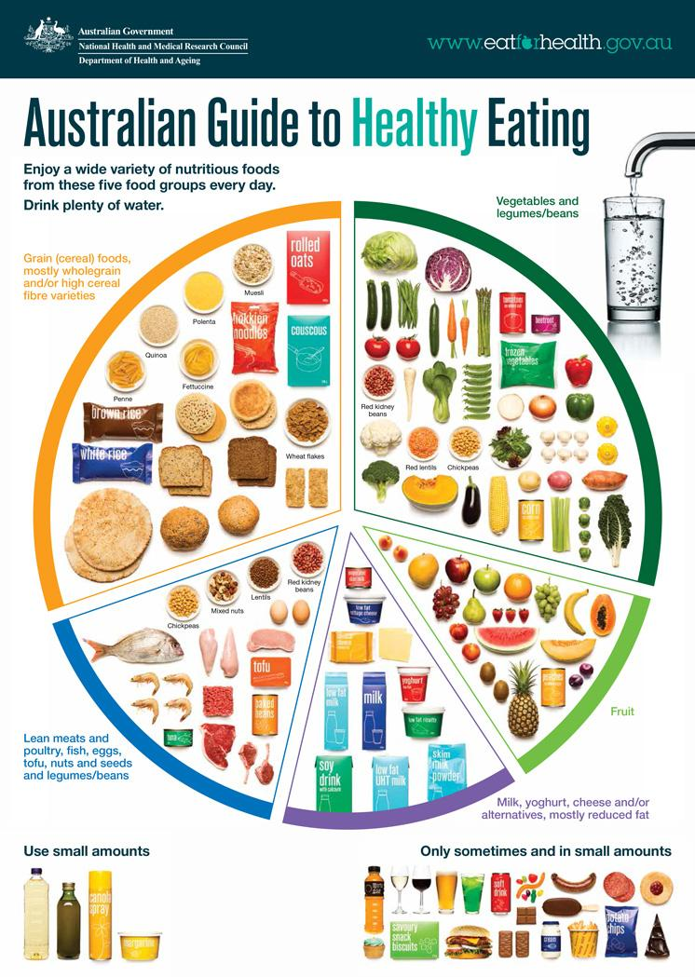
  - This will be evaluated with a given case study

Australian Guide to Healthy Eating
What is it?
- Food selection tool incorporated into the Australian Dietary Guidelines (guidelines 2 & 3)
- Intended for consumers to use it to assist them in planning, selecting and consuming adequate proportions of foods from the 5 food groups
- Government run and funded
How is it used?
- People use it as a guide to ensure they are consuming adequate proportions of a specific food group
- People can plan out their meals to meet the guidelines using the model as a visual representation
- Helps to achieve optimum h&w

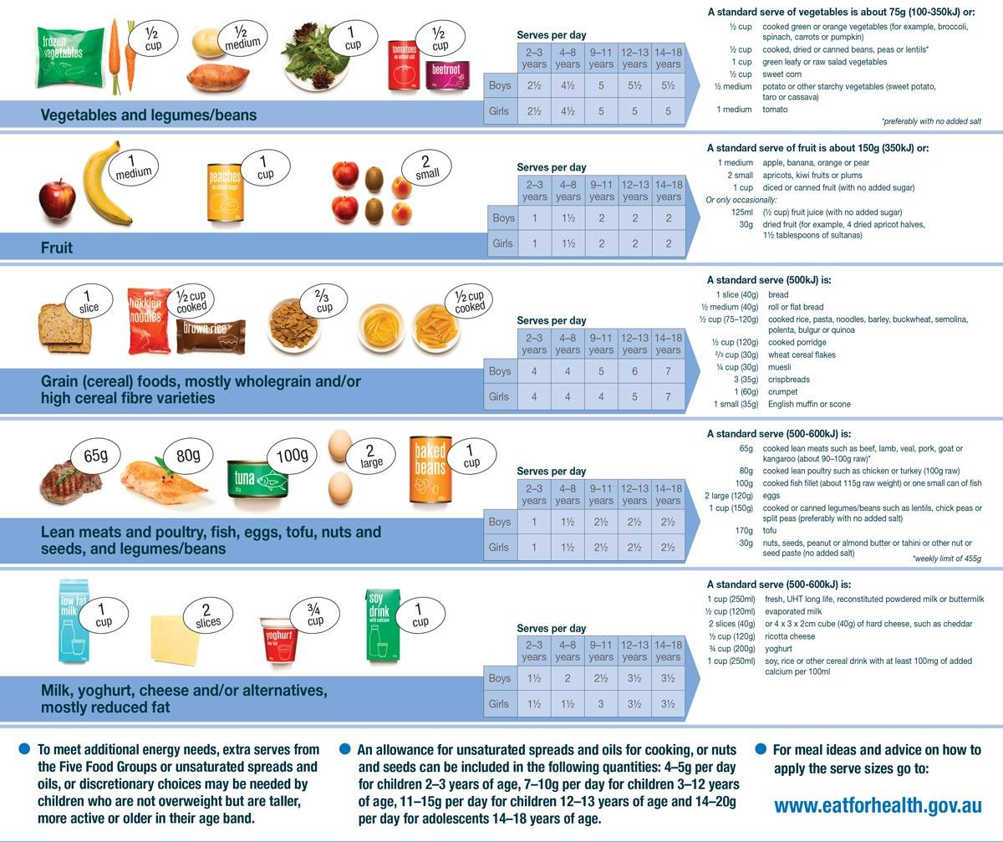
Dietary Guidelines for Australians
Why was it developed?
- Government run and funded
- The Aus population has experienced an increase in diet related conditions and diseases, and the guidelines are designed to address the causes of the increase
How do they cater for individual differences?
- They cater for people at:
  - Different stages of life
  - Pregnant women
  - Different backgrounds
  - Rural or remote areas
  - Different SES groups
  - People wanting to lose or maintain weight
  - Vegetarians or vegans

Their Guidelines
Guideline 1:
- To maintain a healthy weight, be physically active and choose amounts of nutritious food to meet your energy needs
Guideline 2:
- Enjoy a wide variety of nutritious foods from the five food groups every day
  - Plenty of veg, legumes and beans
  - Fruit
  - Grains eg. bread, cereal, rice, pasta, high fibre
  - Lean meats and poultry, fish, eggs, tofu etc.
  - Milk, yogurt, cheese, mostly reduced fat
  - Drink plenty of water
Guideline 3:
- Limit intake of food containing saturated fat, added salt, added sugars and alcohol
- Limit intake of biscuits, cakes, pastries, pies etc.
- Limit intake of foods and drinks containing added salt
- Limit intake of foods and drinks added sugars such as confectionary, sugar sweetened soft drinks etc.
- If you choose to drink alcohol, limit intake. Drinking while pregnant is not a safe option
Guideline 4:
- Encourage, support and promote breastfeeding
Guideline 5:
- Care for your food; prepare and store it safely

Nutrition Australia
Who are they?
- An NGO (non-gov. organisation), but are funded by the Government
- They promote healthy eating by providing the latest info on nutrition research, current food and health and wellbeing trends
Their work:
- Healthy Eating Pyramid (given out to schools and promoted during info sessions by them etc.)
- The Healthy Eating Advisory Service (menu planning, advise school canteens, training and education to chefs)
- Publication of recipes
- Develop educational resources

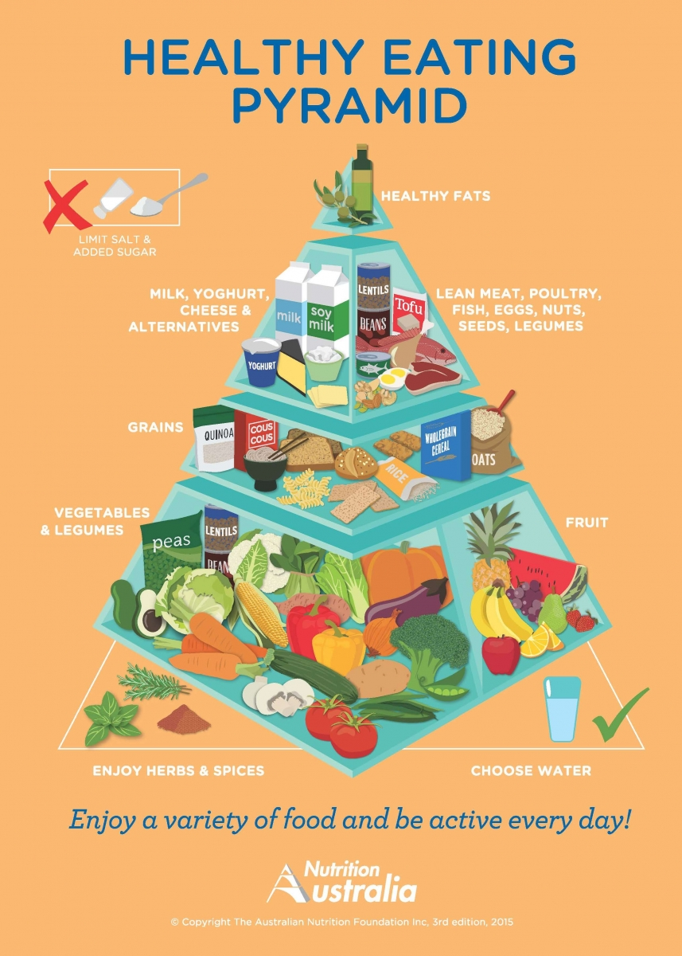
The Healthy Eating Pyramid
- Simple visual guide to the types and proportions of food that promotes healthy food intake
- Old work that is given out to people and schools (it is not their new work!)
- Serving sizes and provisions for composite foods such as pizza are not included, which can make the model difficult to follow
- It contains the five main food groups
  - Fruit
  - Vegetables and legumes/beans
  - Grains, high fibre and mostly wholegrain
  - Dairy
  - Lean meats and poultry, fish, eggs, tofu etc.

The challenges in bringing about dietary change
Attitudes and beliefs
- Number of different diets that people choose which can have varying effects on their health
- Eg. keto diet removes carbs, the body’s main fuel source
- Restricting foods can lead to nutrient deficiencies

Time constraints and conveniences
- For families where both parents work, more time is spent working and less time preparing food
- During time crunches, fast food can be more convenient

Food marketing and media
- Food is advertised a lot in media and looks better in ads than in real life
- Children can be exposed to factually incorrect marketing messages
- Marketers work hard to make food appear desirable, regardless of nutritional value

Personal preference
- People prefer certain foods over others naturally
- Foods high in fat, salt and sugars are flavour enhancers as they stimulate the taste buds, making people more inclined to choose those unhealthy foods
- The cycle creates unhealthy cravings

Family, culture, society and religion
- Cultures or religions have a significant influence on what families consume
- Food preferences can develop through social setting
- In Australia, there is a culture of going to celebrations or parties with a high consumption of alcohol and sugary/fatty foods

U4AOS1

Key Terms - H.S & B.O.D across countries
Gross Domestic Product (GDP) - a measure that reflects the economic state of a country. GDP is the value of all goods and services produced in a country in a 12 month period

Gross National Income (GNI) - the total value of goods and services a country’s citizens produce, including the value of income earned by citizens who may be working in an overseas country

Communicable Diseases - transmissible between people

Non Communicable Diseases - non transmissible between people

Characteristics of high, middle and low income countries
Classifying countries
- Classify as developed or developing
- Developed countries are considered to have a high level of economic development, and are not reliant on primary production like mining and farming
- Developing countries have low economic development and rely on primary production

Income thresholds & examples for the World Bank income grouping classification system
 | GNI per capita range | Examples of countries in this grouping
High income | $12,476 or more | Australia, Canada, Chile, Greece, Ireland, Japan, USA, UK
Upper middle income | $3,036 - $12, 475 | China, Cuba, Fiji, Mexico, South Africa, Turkey, Russian Federation
Lower middle income | $1,026-$4,035 | Cambodia, India, Indonesia, Pakistan, Papua New Guinea
Low income | $1,025 or less | Mali, Nepal, Zimbabwe, Uganda, Somalia

Economic Characteristics
Lower levels of poverty
- Poverty is a lack of access to money
- Low income countries and some middle income countries have a large proportion of their population living in poverty
High average incomes
- Mining, processing, manufacturing, education, healthcare etc.
- Low income countries have limited range of industries, usually centered on farming and primary production
Opportunities for global trade
- High income have access to resources so they can transport goods overseas, and benefit from the trading opportunities
Wide range of industries
- GNI

Social Characteristics
Gender equality
- Lower income countries more affected, due to diff in wages. This affects families and what they can afford etc. housing, food, education for women
- Both males and females in high income have opportunities and choice in education, employment, community participation, family, planning and recreation
Birth and population rates
- Low birth rates and slow population growth is due to access of contraception in high income countries

Education and employment levels
- Low income countries do not have a developed education system, limited career options
- Middle and high income countries, government pays for children's education
Social security systems
- Individuals who are unemployed or unable to work can receive payments from gov
- High economic development and stable political systems
Health systems
- High income countries generally have public health systems
- Low and middle income lack access to suitable healthcare, affecting h&w
Access to technology
- Access to communication systems, internet, medical
- Assists in developing their economies, building trade, furthering educations
- More accessible in high income countries
- Low income countries lack access, impacts ability for education and earning an income
Legal systems
- Unstable governments, low middle income, increase risk of civil conflict
- Strong legal system ensures human rights

Environmental Characteristics
Safe water and sanitation
- Characteristics of high income countries and some middle income
- Access to safe water and sanitation is responsible for variations in h&w
Food security
- People in high income countries generally have access to high quality good supply
- Those in low income countries lack food security
- Natural disasters impact availability of food, however in low income countries they lack financial resources to purchase food in emergencies
Adequate infrastructure
- High income countries usually have adequate roads, piped water, sewage systems, electricity grids and telecommunication systems
- People living in low/middle income lack access to facilities, especially in rural and remote areas
Adequate housing
- Low income often live in substandard housing with poor ventilation
- Urban slums are also a feature
Levels of carbon dioxide
- High income countries emit greater amounts of CO2 per person into the atmosphere
- CO2 emissions are linked to climate change and weather patterns
- Low income countries suffer from climate change as they lack resources to deal with the impacts

Similarities and differences in H.S and B.O.D in low, middle & high income countries
Life Expectancy
- Increased in most countries
- Globally, LE has more than doubled since 1900
- War, conflict and spread of infectious diseases can impact on L.E
- Low and middle income countries suffer more fluctuations in L.E due to above reasons
Mort. & Morb
- U5 mort. rate higher in low and middle income countries as compared to high I.C due to malnutrition, communicable diseases like HIV, malaria etc.
- Causes of mort. and morb. for adults depends on level of income
  - Higher maternal mort. ratio in low income countries compared to high I.C due to lack of sufficient healthcare
Burden of Disease
- Rates of communicable diseases, non communicable diseases and injuries are higher in middle and low income countries, contributing to morb. and mort.
- As a result, low and middle income countries have a greater BOD and higher DALY rates compared to Aus
- YLL & YLD higher in lower and middle income countries

Factors that contribute to similarities and differences in H.S & B.O.D
Access to safe water
- Those in low and middle countries are at greater risk of the effects of unsafe water as they don’t have the infrastructure to supply clean drinking water effectively
- Diseases such as gastro, diarrhea, cholera etc. are waterborne and transmit easily
- It is debilitating for the women who have to walk hours to get clean water while men work (gender inequality)
- Can’t grow crops without water

Sanitation
- One in three people lack access to basic sanitation
- Nearly 1 billion people defecate in the open eg. street gutters, behind bushes
- Contributed to 2% of deaths in 2015
- Girls don’t attend school when on their period
Poverty
- Severe lack of possessions, significantly reducing quality of life, struggle to meet basic needs
- Differences in BOD by reducing access to a range of resources
- A country’s level of GNI affects the government’s ability to access to clean water, sanitation, health services
- Nutritious food: malnutrition because ppl can’t afford nutritious foods, decreases immune system function
- Access to clean water and sanitation: poverty means gov.’s can’t provide clean water and sanitation, increasing the risk of infectious diseases
- Education: reduced access to education results in lower literacy rates, reducing opportunities for employment, influencing the cycle of poverty and impacting access to food = malnutrition etc.
- Healthcare: poverty usually results in an inability to afford healthcare in low income countries. High income countries eg. Australia has Medicare for all Australians regardless of income
- Housing: in low and middle income countries, poverty means people live in inadequate housing which contributes to ill health.
Inequality and discrimination (race, religion, sex, sexual orientation)
- Race: indigenous people suffer higher rates of ill health and disability and have a shorter life expectancy
- Religion: communities face discrimination based on religion, resulting in an ability to realise their human rights
- Sex: when women have the same power and control over their lives as men, HS improves
- Forced marriage: child brides face a higher risk of contracting AIDS when they marry older men with greater sexual experience
- Female genital mutilation: intentionally cutting out female genital organs for non-medical reasons. FGM causes severe pain, excessive bleeding, infections etc.
- Sexual orientation: those who do not identify as heterosexual often are subjected to discrimination, and are refused jobs, refused healthcare, subjected to assault etc.
Global distribution and marketing of tobacco, alcohol and processed foods
- Tobacco manufacturers target low and middle income countries
- High income countries like Australia have laws, taxes and regulations around smoking
- Global alcohol consumption has increased in recent decades
- Most of the increase comes from low and middle income countries as manufacturers market towards them
- Processed foods are more marketed towards low and middle countries for years
Key Terms - Sustainability
Economic sustainability - ensuring average incomes in all countries are adequate to sustain a decent standard of living and continue to rise in line with inflation

Environmental sustainability - ensuring the natural environment is used in a way that will preserve resources into the future

Human development - creating an environment in which people can develop to their full potential and lead productive, creative lives according to their needs and interests.

Human Development Index - tool developed by the UN to measure and rank countries’ levels of social and economic development. Based on 3 dimensions - a long and healthy life, knowledge, and a decent standard of living, and 4 indicators - LE at birth, mean yrs of schooling, expected yrs of schooling and GNI.

Social sustainability - creating an equitable society that meets the needs of all citizens and can be maintained indefinitely

Sustainability - meeting the needs of the present without compromising the ability of future generations to meet their own needs

Sustainability
- Meeting today’s needs and planning the country’s growth without creating problems or depleting resources for future generations
- United Nations considers three dimensions of sustainability
  - Economic sustainability
  - Social sustainability
  - Environmental sustainability

Economic Sustainability
- Ensuring average incomes in all countries are adequate to sustain a decent standard of living and continue to rise in line with inflation and living costs of the future
Provides health and wellbeing by:
Ensuring all people earn a decent income
- purchase health promoting resources eg. food, shelter, education, basic healthcare
It can increase the capacity of governments to provide services and infrastructure
- provision of infrastructure for clean water and sanitation promotes physical h&w
Ensuring children stay in school
- Children not forced into labour due to poverty, promoting social interaction

Social Sustainability
- Creating an equitable society that meets the needs of all citizens
Provides health and wellbeing:
Elimination of poverty and the provision of social protection systems
- If poverty is eliminated
  - It reduces the risk of infectious diseases, promoting physical h&w
  - Increase mental health as people are less likely to experience stress when thinking about accessing food etc.
  - Enable people to better deal with misfortune, promoting emotional h&w
Gender equality
- Removing discrimination and violence against women promotes physical h&w, decreased stress levels
Access to safe and decent working conditions
- Safe conditions mean people can have meaningful employment, including those with a disability
- Access to good working conditions can end child labour, improving their education, promote physical h&w
Promotion of political and legal rights
- Develop policies preventing discrimination, reducing anxiety - promote mental h&w
- Address violence against women, promote physical h&w
Peace and security
- Financial resources not directed to war effort, so gov. can provide money towards infrastructure, education and healthcare
- Adults can work and children can continue to go to school, promote social h&w

Environmental Sustainability
- ensuring the natural environment is used in a way that will preserve resources into the future
Biodiversity
- Ecosystems promote h&w thru provision of oxygen and removal of carbon dioxide
Use of natural resources
- damaged delicate ecosystems impact physical h&w eg. can’t get crops for fruit and veg
Waste removal and pollution
- suitable access to clean water prevents infectious diseases and promotes physical h&w
Climate change
- Ecosystems can be maintained if temperatures do not continue to rise, providing clean water, air etc. which promotes physical h&w

Interrelationships between the three dimensions of sustainability
- access to safe water is an aspect of social sustainability, but relies heavily on environmental sustainability to ensure clean water is available
- Environmental sustainability is considered the largest dimension because social and economic sustainability depend on it

Human Development
- Creating an environment where people can develop to their full potential
- Lead productive, creative lives according to their needs

HDI is a tool developed by the UN to measure and rank levels of social and economic development in countries
HDI is measured by:
- Dimensions — indicators
- Long and healthy life — life expectancy at birth
- Knowledge — mean years of schooling and expected years of schooling
- Decent standard of living — GNI per capita

Advantages and disadvantages of HDI
Advantages
- considers more than average income
- Reflects access to knowledge
- Reflects access to the resources needed for a decent standard of living
- Makes comparison easy
Disadvantages
- HDI is based on averages, doesn’t display inequalities within countries
- Collecting data is complex & not always reliable
- HDI only reflects selected aspects of human development, things like gender equality, freedom of speech etc. are not measured

Implications for health and wellbeing of global trends
Climate change
- Rising sea levels
  - Causes relocation of farms and villages, causing stress
  - Reduces access to fresh water
  - Reduction in food supplies
- Increase in extreme weather patterns
  - Increases the prevalence of infectious diseases
  - Extreme temperatures effects elderly and young, can trigger asthma
  - Low income countries lack the resources to deal with natural resources

Conflict and mass migration
Physical
- Malnutrition and injuries, higher infant mortality rate
- Increase in communicable diseases
Mental
- Living in fear
- Women and children can be vulnerable
- PTSD
Spiritual
- Loss of sense of belonging
Social
- Loss of friends and connections
Refugee - person forced to leave their country eg. war
Asylum seeker - seeking protection and yet to have refugee status determined
Internally displaced peoples - choose to stay in their country

Increased world trade and tourism
- Trade allows countries to specialise and promote competition
- Helps economic growth
- Provide jobs
- Decrease poverty
- Able to earn a living

- Tourism promotes sustainable economic growth (education, employment)
- Promotes social inclusiveness and gender equality (mental h&w)

Digital technologies
- Can help people in low income countries train and learn about health at a low cost
- Phones can be used in natural disasters
- Technology can help to detect incoming natural disasters

U4AOS1

SDGs - Sustainable Development Goals
- 169 targets to be achieved by 2030, set by the UN
- Tackle 5 key areas
  - People (poverty)
  - Planet (protect planet from degradation)
  - Prosperity (live fulfilling lives)
  - Peace (societies free of fear & violence)
  - Partnership (participation of all countries to achieve SDGs)

Rationale for the SDGs (reasons)
1. New target needed after MDGs ended in 2015
2. Progress in all areas was uneven across regions and countries
3. New global challenges had emerged

Objectives of the SDGs
- End extreme poverty
- Fight inequality and injustice
- Address climate change

SDGs | Definition
SDG 1 - no poverty | End poverty in all its forms everywhere
SDG 2 - zero hunger | End hunger, achieve food security and improved nutrition, promote sustainable agriculture
SDG 3 - good h&w | Ensure healthy lives and promote good h&w at all ages
SDG 4 - quality education | Ensure inclusive and equitable quality education and promote lifelong learning opportunities for all
SDG 5 - gender equality | Achieve gender equality and empower all women and girls
SDG 6 - clean water & sanitation | Ensure availability and sustainability management and sanitation for all
SDG 13 - climate action | Take urgent action to combat climate change and its impacts

SDG 3 - *key features* of good health and wellbeing:
- “Ensure healthy lives and promote wellbeing for all at all ages”
- SDG 3 aims to improve physical and mental h&w in all countries by reducing mort and morb due to common causes
- Aim to reduce maternal, infant, under 5 mort and premature mort from both communicable and non-communicable diseases
- Aims to reduce injuries and deaths from road trauma and address substance abuse
- Aim to ensure universal health coverage & access to sexual/reproductive HC services

1. Reduce maternal mortality
Most deaths occur as a result of:
- Haemorrhage (excessive bleeding)
- Sepsis (infection in whole body)
- Obstructed labour
- Unsafe abortion
- Hypertensive disease
Improvements in maternal mortality rates
- More women having access to sexual/reproductive health
- More births being assisted by skilled health personnel
- Fewer adolescent girls becoming pregnant
- Greater access to family planning services
Achieving targets
- Safe childbirth practises, effective neonatal care
- Deaths of children u5 are due to preventable causes eg. malnutrition, measles etc
- Breastfeeding, access to safe water, access to h&w eg. vaccinations, antibiotics
- Adequate nutrition is also important to reduce U5 mort

2. End preventable newborn and child deaths
- Many infant deaths occur in the neonatal period
- Up to half of deaths occur within the first 24 hours of birth
- 48 hours immediately following birth is the most crucial
Improvements in infant and child h&w
- Global u5 mort rate was reduced by more than half between 2000 & 2015
Achieving targets
- Preventable deaths of newborns & those U5 can be reduced by ensuring mothers have access to safe childbirth practises & neonatal care
- Breastfeeding, access to safe water, access to h&w eg. vaccinations, antibiotics
- Many deaths of children U5 are from preventable causes
- Adequate nutrition is important to reduce U5 mort rate

3. Communicable diseases
- Diseases transmitted through environment, people, air, water, food

AIDS/HIV
¼ Kenyans living with HIV
- ⅔ children living with HIV don’t receive medications
- SDG3 aims to end epidemic of AIDS by 2030
Ending the epidemic of AIDS
- Condoms
- Circumcision
- Pre-exposure medication
- Education
- Gender equality
Improvements
- More effective diagnosis
- Treatments always being worked on
- Spraying insecticides in homes

Malaria
- Happening in 91 countries
Ending the epidemic
- Financial investment
- Access and distribution of nets
- New control strategies
- Access to clean water & sanitations

Tuberculosis
- Highly contagious
- Breaks down lung tissue, can cause death
- Treatable with drugs
Improvements
- Prevention, diagnosis and treatment
- Vaccinations
Ending the epidemic
- TB is in top 10 causes of death
- Access to drug treatment
- Increase vaccinations
- Research

4. Non-communicable diseases
Reducing mort from non-comm. diseases
- The WHO recommends that countries:
  - Implement taxes on alcohol & tobacco products
  - Legislate for food labels to include easy to understand info
  - Schools and workplaces encourage PA

Mental h&w
- Mental disorders such as depression are among the 20 leading causes of disability worldwide
- Can be treated effectively with meds and psychological support
  - Needs to be more development and implementation of strategies to promote good h&w
  - More investment in mental health services

Reducing BOD in road accidents
- Leading cause of mort in 15-29 yr olds
- SDG 3 aims to halve no. of global deaths and injuries from road traffic accidents by 2020 (not 2030)
- Needs transport sector, police, health and education sectors involved

Reducing BOD with drug & alcohol misuse
- Cost of treating drug-dependent people worldwide would be US $250 billion
- Greater funding is required to strengthen prevention and treatment services

Reducing mort & morb from hazardous chemicals in air, water etc.
- Low and middle income countries experience largest environmental risks that can be prevented
- Air pollution causes stroke, heart disease and respiratory infections
- Contaminated drinking water causes diarrhoeal diseases, malnutrition, intestinal worms
- Governments need to provide incentives for clean energy, waste management, rigorous monitoring of air pollution levels

SDG 3 Promoting PEMSS
Physical h&w - reduced risk of water borne and communicable diseases = absence of disease, improve immune systems, body can function effectively
Mental h&w - reduce financial stressors of worrying about paying for healthcare
Social h&w - when children aren’t sick they can develop social networks
Spiritual h&w - with less rates of illness people can participate in activities, make them feel like they belong
Emotional h&w - when people overcome illness, they can manage and recover from unfortunate situations, building resilience and optimism

Human Development: create an environment where people can develop to their full potential, lead productive and creative lives according to their needs
- Long and healthy life
- Knowledge
- Decent standard of living

SDG3 Promoting Human Development
- Reduce stigma around mental health, people can participate in their community
- Reduce rates of infant & u5 mort, children can grow up and reach full potential
- Achieving universal health coverage means ppl can access health services needed without spending lots of money - reach a decent standard of living
- Implementing public health promotion campaigns increases knowledge in communities

The SDGs are interconnected
- One goal is not more important than any other
- They all complement each other and are interconnected
- Achievement is dependent on the collaboration of all sectors

➜ Relationship between SDG1 (no poverty) and SDG3 (good h&w)
- If poverty is eradicated, people can afford health care to be vaccinated against many communicable diseases
- Promotes good h&w by reducing incidence of tuberculosis, hepatitis, AIDS/HIV

➜ Relationship between SDG2 (zero hunger) and SDG3 (good h&w)
- Achieving food security in all countries means everyone consumes a nutritious diet, reducing BOD from nutrient deficiency diseases eg. anaemia
- When pregnant women consume adequate diets, it reduces maternal mort. rates from deficiency diseases, birthing complications, low birth weight babies reducing u5 mort

➜ Relationship between SDG4 (quality education) and SDG3 (good h&w)
- Enhanced literacy skills allow people to better understand health promotion messages and understand risk factors of poor health eg. poor diets, excessive alcohol
- Enables people to make better health decisions and basic health practises to reduce incidence from communicable diseases
- Having an education increases employment prospects, stable incomes means people can afford healthcare, nutritious foods, shelter

➜ Relationship between SDG5 (gender equality) and SDG3 (good h&w)
- Gender equality is the foundation for a sustainable world, inequality hinders ability to achieve global health
- If women are educated, they can not only access quality employment but better take care of their family eg. buy nutritious food, practise hygienic behaviours
- The public health sector will work together with the health sector to work towards achieving SDG 5 and 3

➜ Relationship between SDG6 (clean water & sanitation) and SDG3 (good h&w)
- Unpolluted water = reduced risk of contracting water borne diseases from drinking water, reducing BOD from communicable conditions like malaria, cholera, hep A
- Access to waste removal systems improves air quality, reducing morb and mort from air borne diseases
- Access to safe drinking water strengthens the immune system, reducing mort from preventable diseases
- Water sanitation sector will work together with the health sector to work towards achieving SDG 6 and 3

➜ Relationship between SDG13 (climate action) and SDG3 (good h&w)
- Unpredictable rainfall patterns causing floods/droughts make it increasingly difficult for farmers to grow crops, making it hard for countries to achieve food security. Droughts cause malnutrition and famine in many low income countries, weakening immune systems
- Global warming is slowly destroying the ozone layer = increases effects of UV radiation and increasing BOD of skin cancer
- Natural disasters cause drowning, destroy homes, same a fires. Affects health care services if they are directly impacted
- The environmental sector will work together with the health sector to work to achieve SDG 13 and 3

Priorities and work of the WHO
- ‘Thirteenth general programme of work, 2019-2023’ has a strategic direction based on the SDGs with a commitment to achieve goal 3
- Three specific priorities that are interconnected
  - Achieve universal health coverage (UHC)
  - Addressing health emergencies
  - Promote healthier populations

UHC - 1 billion more people benefitting from UHC
- WHO aims to progress toward UHC by addressing:
  - Service access and quality
  - Access to meds, vaccines and health products
  - Health info systems
Health emergencies - 1 billion more people better protected from health emergencies
- Building and sustaining resilient national, regional and global capacities required in keeping the world safe from epidemics and other emergencies
- Ensure populations affected by acute emergencies have rapid access to essential life-saving health services including health promotion and disease prevention
Healthier populations - 1 billion more people enjoying better h&w
  - Action in preventing non-comm. diseases & mental health
  - Elimination & eradication of high impact comm. diseases
  - Address health effects of climate change in small island developing states & others vulnerable

Foreign Aid
➜ Emergency/humanitarian aid
➜ Bilateral aid
➜ Multilateral aid

Emergency/humanitarian aid
- Rapid assistance is given to people or countries in immediate distress to relieve suffering during or after man-made emergencies (wars, conflicts) and natural disasters
- Short term, purpose is to keep people alive
- Provision of food, medicine and shelter
- Health workers, doctors, emergency workers from other countries
- Assisting communities to rebuild houses and infrastructure so there is sufficient access to sanitation, food, clean water and healthcare
Limitations
- Does not address the underlying causes of poverty
- Is the ‘quick fix’ approach similar to the biomedical model of health, not sustainable in the long term

Bilateral aid
- Aid from one government to the other
- The donating country works with the government of the country receiving the aid to make sure the implemented program meets specific needs
- Small scale, community based, commonly education focused
  - Small community immunisation programs
  - Water treatment plant in a village
  - Aus gov providing funding to Papua New Guinea for prevention, treatment and education of HIV/AIDS
Advantages:
- Needs of receiving country are met
- Capacity to assist of the donating country is met
Limitations:
- Attracts criticism as the products being provided by the donating country are products of country who are donating, benefitting their economy
- Public considers and challenges true intentions of the donating country, are they doing it for their own gain?

Multilateral aid
- Assistance is provided through an international organisation eg. UN, WHO
- International organisations combine donations from a number of countries and distribute it to the recipients in the developing countries
- Long term and large scale
- Addresses issues that affect the planet on a global level eg. global warming, controlling disease outbreak
Advantages:
- Because funds from multiple countries are being combined, a greater impact can be generated and larger projects can be achieved
Disadvantages:
- Very low level of communication
  - Governments in individual countries don’t have a say in where the money goes

Australian Government’s Aid Program
- Department of Foreign Affairs and Trade (DFAT)
- Purpose is to promote Aus’s international interests by contributing to sustainable economic growth and poverty reduction
DFAT achieves this by participating in a variety of aid:
Emergency aid
- DFAT provides humanitarian aid to countries in need
- Send health professionals from Aus to a country in need, providing food, water, shelter
Bilateral aid
- Aus forms bilateral partnerships with governments from developing countries & work directly with them to provide assistance
Multilateral aid
- Aus provides funds to international organisations such as the UN to help them assist countries in need of major infrastructure projects

Features of Australia’s DFAT program - BAGIEE acronym
- Building resilience, humanitarian assistance, disaster risk reduction and social protection
- Agriculture, fisheries and water
- Gender equality, empowering women and girls
- Infrastructure, trade facilitation and international competitiveness
- Education and health Gender equality, empowering women and girls
- Effective governance, policies, institutions and funding economies

NGOs
Care Australia
- NGO that aims to eliminate global poverty, with a focus on working with women to support lasting change in the community
- We Bloom Program promotes education for women in Cambodia
- Economic development by supporting money making activities, especially by women
- Access to health services, family planning, immunisation for mothers
- Preparing for disasters through focusing on land & agriculture management
- Provide emergency relief such as food, medicine and shelter to affected areas
- Encourage food security through Health and Nutrition projects in Indonesia
- Health interventions eg. TB control and treatment, malaria reduction, pre natal and neonatal care, hygiene promotion
- Enables access to clean water & basic sanitation through rural sanitation and water supply projects in Papua New Guinea through new pipeline systems

Other NGOs
- Red Cross
- Oxfam
- World Vision

Features of effective aid
Ownership
- Countries receiving the aid must decide the type of aid that will best suit their needs and how the program will be implemented
Partnerships
- Participation of all stakeholders is crucial
- Eg. gov of the recipient country, gov of donor countries, NGO all need to work together
Focus on results
- Making a difference and having a lasting impact is the main purpose of a program
Transparency and accountability
- All necessary info is made available to everyone involved in the program, as well as regular monitoring and assessing progress
Programs to address the SDGs
- Purpose, SDG being addressed, details of implementation, how it promotes HD & h&w

Aid programs that address the SDGs
Program for SDG 1, 2, 3, 4, 5, 6 - Nuton Jobon Livelihood program in Bangladesh
- Purpose is to improve livelihood
- Partnership with Bangladeshi gov and social development foundation
- H&w - as poverty can cause malnutrition impacting physical/emotional h&w
- Human development - people can have a decent standard of living so they can have a long life

Social action
- Doing something to help create positive change
- Demonstrations, rallies, marches, political pressure, volunteer programs, donating money, signing petitions

