health issue: smoking
why it was/is targeted. | effectiveness of the health promotion in improving population health. | how the health promotion reflects the action areas of the ottawa charter for health promotion
- smoking is a preventable risk factor for several diseases, making health promotion possible.  - a contributor to lung cancer, one of the leading causes of death in australia.  - it affects vulnerable population groups disproportionately, including those of a low ses, those living outside australia's major cities and indigenous populations. | - there has been a delay in the uptake of smoking.  - smokers are smoking fewer cigarettes  - fewer people are being exposed to second-hand smoke.  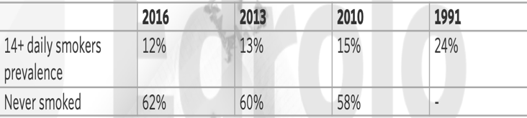 | the quit program overall  - build health public policy: working with the government to ban smoking in outdoor areas.  - create supportive environments: quitline, quitcoach and quittext are all online platforms to materials assisting smokers to quit, creating several supportive environments for smokers quitting.  - strengthen community action: quit works specifically with community groups to increase success of quitting, ensuring they are working together to bring about improvements.  - develop personal skills: the program provides practical advice on quitting (personal plan to avoid smoking around other people who smoke), developing people’s personal skills and knowledge on the strategies and benefits of not smoking.  - reorient health services: quit provides specialist training to health professionals to undertake interventions and referrals to quitline in order to work to prevent related disease rather than need to take a biomedical approach to health.

