**INITIATIVES TO PROMOTE HEALTHY EATING IN AUSTRALIA**

* **The Australian Dietary Guidelines**
* **The Australian Guide to Healthy Eating**
* **Nutrition Australia**
* **Challenges in bringing about dietary change**

Sandra Fordyce-Voorham

**Use this booklet with the PowerPoint used in class**

**NAME:______________________________________**

AUSTRALIAN DIETARY GUIDELINES

|  |
| --- |
| Who developed this initiative? |
| Why were they developed? |
| Who can use the guidelines? |
| The ADG have been developed to provide advice relating to the types and amounts of foods, food groups and dietary patterns that will help Australians to: |
| Advice is also provided for: |

AUSTRALIAN DIETARY GUIDELINES

|  |
| --- |
| **GUIDELINE 1** |
| **GUIDELINE 2** |
| **GUIDELINE 3** |
| **GUIDELINE 4** |
| **GUIDELINE 5** |

AUSTRALIAN DIETARY GUIDELINES SERVING SIZES - CASE STUDY page THREE HUNDRED & ELEVEN

1. Identify the number of serves of each food group consumed by Anna into the table below:

|  |  |  |  |  |  |  |  |
| --- | --- | --- | --- | --- | --- | --- | --- |
| Serves | Vegetables and legumes beans | Fruit | Grain (cereal) foods, mostly wholegrain and/or high cereal fibre varieties | Lean meats, poultry, fish, eggs, tofu, nuts and seeds, and legumes/beans | Milk, yoghurt, cheese and/or alternatives, mostly reduced fat | Unsaturated spreads and oils | Discretionary foods |
|  |  |  |  |  |  |  |  |

1. Compare Anna’s intake to the guidelines given in Table p303
2. a. Which food groups did Anna consume the optimal amount?

b. Explain how consuming an optimal amount of these foods might promote Anna’s health & wellbeing.

1. a. Which foods groups did Anna not consume enough?

b. Explain how how not consuming an optimal amount of these foods might affect Anna’s health & wellbeing

5. a. Which food groups did Anna consume too much?

b. Explain how consuming too much of these foods might affect Anna’s health & wellbeing

6. Comment on Anna’s water consumption

7. Why would it be more accurate to assess food intake over 3 days instead of 1?

8. Suggest modifications Anna could make to his diet to more closely reflect the recommendations of the ADG’s



AUSTRALIAN GUIDE TO HEALTHY EATING

|  |
| --- |
| What is this tool? |
| What does each wedge in the circle represent? |
| What else does this tool recommend? |
| What is shown in the bottom right hand corner of the tool? |
| What are the limitations of this tool? |
| How does this tool differ from the ADG’s? |

Healthy Eating Pyramid

The Healthy Eating Pyramid is a simple visual guide to the types and proportion of foods that we should eat every day for good health.

It contains the five core food groups, plus healthy fats, according to how much they contribute to a balanced diet based on the Australian Dietary Guidelines.

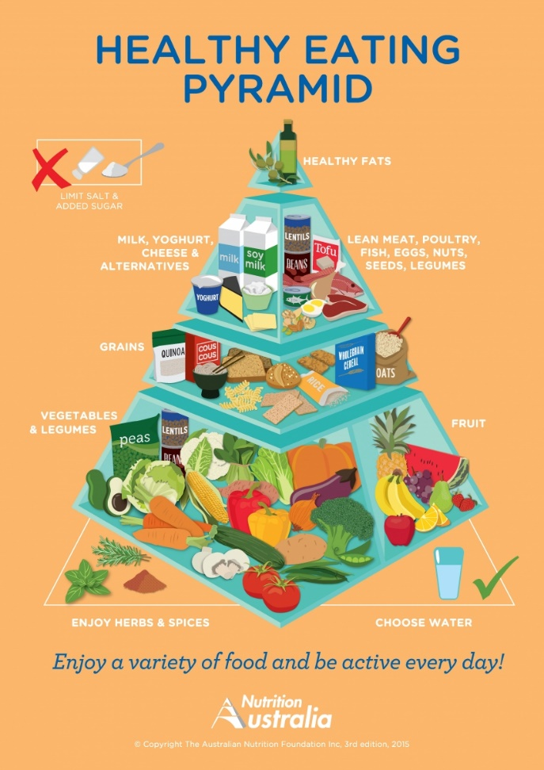

|  |
| --- |
| What is the Healthy Eating Pyramid? |
| Who developed it? |
| Explain the layers?  What are the recommendations outside the pyramid?  How does this tool differ from the ADG’s or the AGHE? What are the similarities? |

Nutrition Australia

|  |
| --- |
| the work of nutrition australia includes: |
| The Healthy Eating Pyramid |
| Healthy Eating Advisory Service |
| National Nutrition Week |
| Develop educational resources |
| Nutrition seminars and workshops |
| Webinars for health professionals |
| Publication of recipes |

The challenges in bringing about Dietary Change

Use fig 7.51 p 321 to explore the factors that influence our food intake in the spaces below

Complete Case studies on p 324 (Fat Tax) and p 327 (Junk food)

|  |  |
| --- | --- |
| Food security |  |
| Willpower |  |
| Attitudes and beliefs |  |
| Personal preference |  |
| Time constraints and convenience |  |
| Education, nutrition and cooking skills |  |
| Influence of family, culture, society and religion |  |
| Food marketing |  |
| Health and wellbeing factors |  |