**MEDICARE**

**Medicare is Australia’s universal health insurance scheme**

Medicare provides free or subsidized medical treatment to all Australian citizens, permanent residents and those from countries with a reciprocal agreement eg New Zealand, Ireland, UK & Sweden.

**Medicare provides free treatment in public hospitals for a public patient.**

If a person is admitted to a private hospital Medicare will pay 75% of the schedule fee

*Schedule fee: The Gov’t decides what each item is worth and that’s what Medicare pays. Doctors may charge more than the schedule fee*

**Medicare provides subsidised treatment for:**

Doctors and specialists services

X-rays and pathology

Eye tests performed by optometrists

***\*Unless these services are bulk-billed a patient co-payment is required (p244)***

*Bulk billing: The medical practitioner bills Medicare directly, accepting the Medicare rebate as full payment for the service.*

**Medicare does not provide subsidies for**:

* anything that is not considered ‘clinically necessary’ such as cosmetic surgery
* Dental care
* Home nursing
* Ambulance services
* Most alternative therapies eg.natural medicine and acupuncture (unless referred by a GP).

**Medicare Safety Net** provides extra financial assistance for those that incur significant co-payment costs for Medicare services in a 12 month period. One co-payments reach a threshold services become cheaper for the rest of the year.

**Medicare is funded in three ways:**

* **Medicare Levy** – 1.5% of taxable income for most tax payers (except those on low incomes)
* 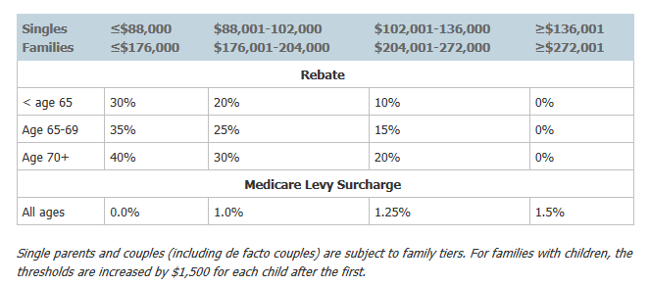**Medicare Levy Surcharge** – an additional tax paid by high income earners who do not have private health insurance. The amount of tax paid depends on income.
* **General Income Tax** – the Medicare Levy and Medicare Surcharge do not raise enough funds, so money from general income tax is also contributed towards Medicare.

**PHARMACEUTICAL BENEFITS SCHEME**

The Pharmaceutical Benefits Scheme (PBS) gives all Australian residents and eligible overseas visitors access to prescription medicine in a way that is affordable, reliable and timely.

The cost of listed prescription medicine are subsidised making it more affordable for all Australians.

The co-payment is the amount you pay towards the cost of your PBS medicine. Many PBS medicines cost a lot more than you actually pay as a co-payment. Users pay around $36.90 per prescription (this figure is updated on January 1 each year in line with inflation), concession card holders pay less $6.00

Over 4000 medications included.

**The PBS Safety Net** assist individuals and families if their out of pocket expenditure on PBS listed medicines exceed a certain amount in a 12 month period.

**PRIVATE HEALTH INSURANCE**

**Private health insurance is a type of medical insurance that can be taken out in addition to Medicare.**

Users pay a premium to join a scheme.

It provides members with greater choice with regards to their health care:

* Will cover some or all of the extra costs associated with private hospitals (Medicare contributes 75% of what it would pay if the treatment was in a public hospital)
* Choice of hospital
* Choice of doctor
* Reduced waiting times
* Can opt for extras (cover for services not covered by Medicare such as dental and physiotherapy)

**Private health insurance provides necessary funding for the health system**.

As a result, the Federal Government has devised numerous incentives to encourage it use:

* **Lifetime Health Cover** – designed to encourage people to take out hospital insurance earlier in life and to maintain their cover.

Those who take out private health insurance over the age of 30 pay an extra 2% on their premiums for every year they are aged over 30 eg. If you take out hospital cover at age 40 you will pay 20% more than someone who first took out hospital cover at age 30. The maximum loading is 70%.

Once you have paid a LHC loading on your private hospital insurance for 10 continuous years, the loading is removed as long as you retain your hospital cover

* **Medicare Levy Surcharge** – high income earners without private health insurance pay an extra tax (see notes on medicare)
* **Private Health Insurance Rebate** – the Federal Government will pay a percentage of the premiums paid for eligible private health insurance members. The amount paid depends on income. Higher income earners receive a lower/no rebate. (see table above)

|  |  |  |
| --- | --- | --- |
|  | **Advantages** | **Disadvantages** |
| Medicare |  |  |
| Private health insurance |  |  |

1. Australia’s health system is made up of numerous government and non-government organisations and initiatives.

The Federal Government has numerous roles in promoting health in Australia. One example is Medicare.

a. Describe Medicare 3 marks

|  |
| --- |
|  |
|  |
|  |
|  |
|  |

b. Which model of health does Medicare mainly reflect? 1 mark

|  |
| --- |
|  |

c. Private health insurance is another key aspect of Australia’s health system.

i. Briefly explain private health insurance. 2 marks

|  |
| --- |
|  |
|  |
|  |

ii. Identify and explain two incentives put in place by the Federal Government to encourage individuals to take out private health insurance. 4 marks

|  |
| --- |
|  |
|  |
|  |
|  |
|  |
|  |
|  |

d. Identify the Federal Government’s pharmaceutical subsidy scheme. 1 mark

|  |
| --- |
|  |

**Question 2**

The following table shows the total number of Medicare services and total cost of Medicare as well as the average number of Medicare services per person and average cost per person.

|  |  |  |  |  |
| --- | --- | --- | --- | --- |
|  | **Services covered by Medicare (number)** | | **Cost of all Medicare services** | |
| **Year** | **Total (million)** | **Per person** | **Total $ millions** | **Per person $** |
| 2001–02 | 220.7 | 11.2 | 7 829.5 | 398.4 |
| 2002–03 | 221.4 | 11.1 | 8 115.5 | 407.8 |
| 2003–04 | 226.4 | 11.2 | 8 600.0 | 427.0 |
| 2004–05 | 236.3 | 11.6 | 9 922.9 | 486.2 |
| 2005–06 | 247.4 | 11.9 | 10 976.3 | 530.2 |
| 2006–07 | 257.9 | 12.3 | 11 735.6 | 558.8 |
| 2007-08 | |  | | --- | | 278.7 | |  | | 13.1 | 13 006.5 | 612.40 |
| 2008-09 | 294.0 | 13.5 | |  | | --- | | 14 321.9 | | |  | | --- | | 664.30 | |
| 2009-2010 | 308.4 | 13.9 | 15 400.0* | 696.83 |

* denotes estimate only. Source: Jacaranda, Key Concepts in Health and Human Development 2E, 2012.

a. Describe the trend in differences in total Medicare expenditure between 2001-02 and 2009-10.

2 marks

|  |
| --- |
|  |
|  |
|  |

b. How many Medicare services, on average, did each person have in 2009-2010? 1 mark

|  |
| --- |
|  |

c. Identify two services covered by Medicare that contribute to total Medicare expenditure. 2 marks

|  |
| --- |
|  |
|  |
|  |

d. Explain how Medicare is funded. 3 marks

|  |
| --- |
|  |
|  |
|  |
|  |
|  |

e. Name the level of Government responsible for administering Medicare. 1 mark

|  |
| --- |
|  |

**Question 4**

The following graph shows private health insurance membership over time.

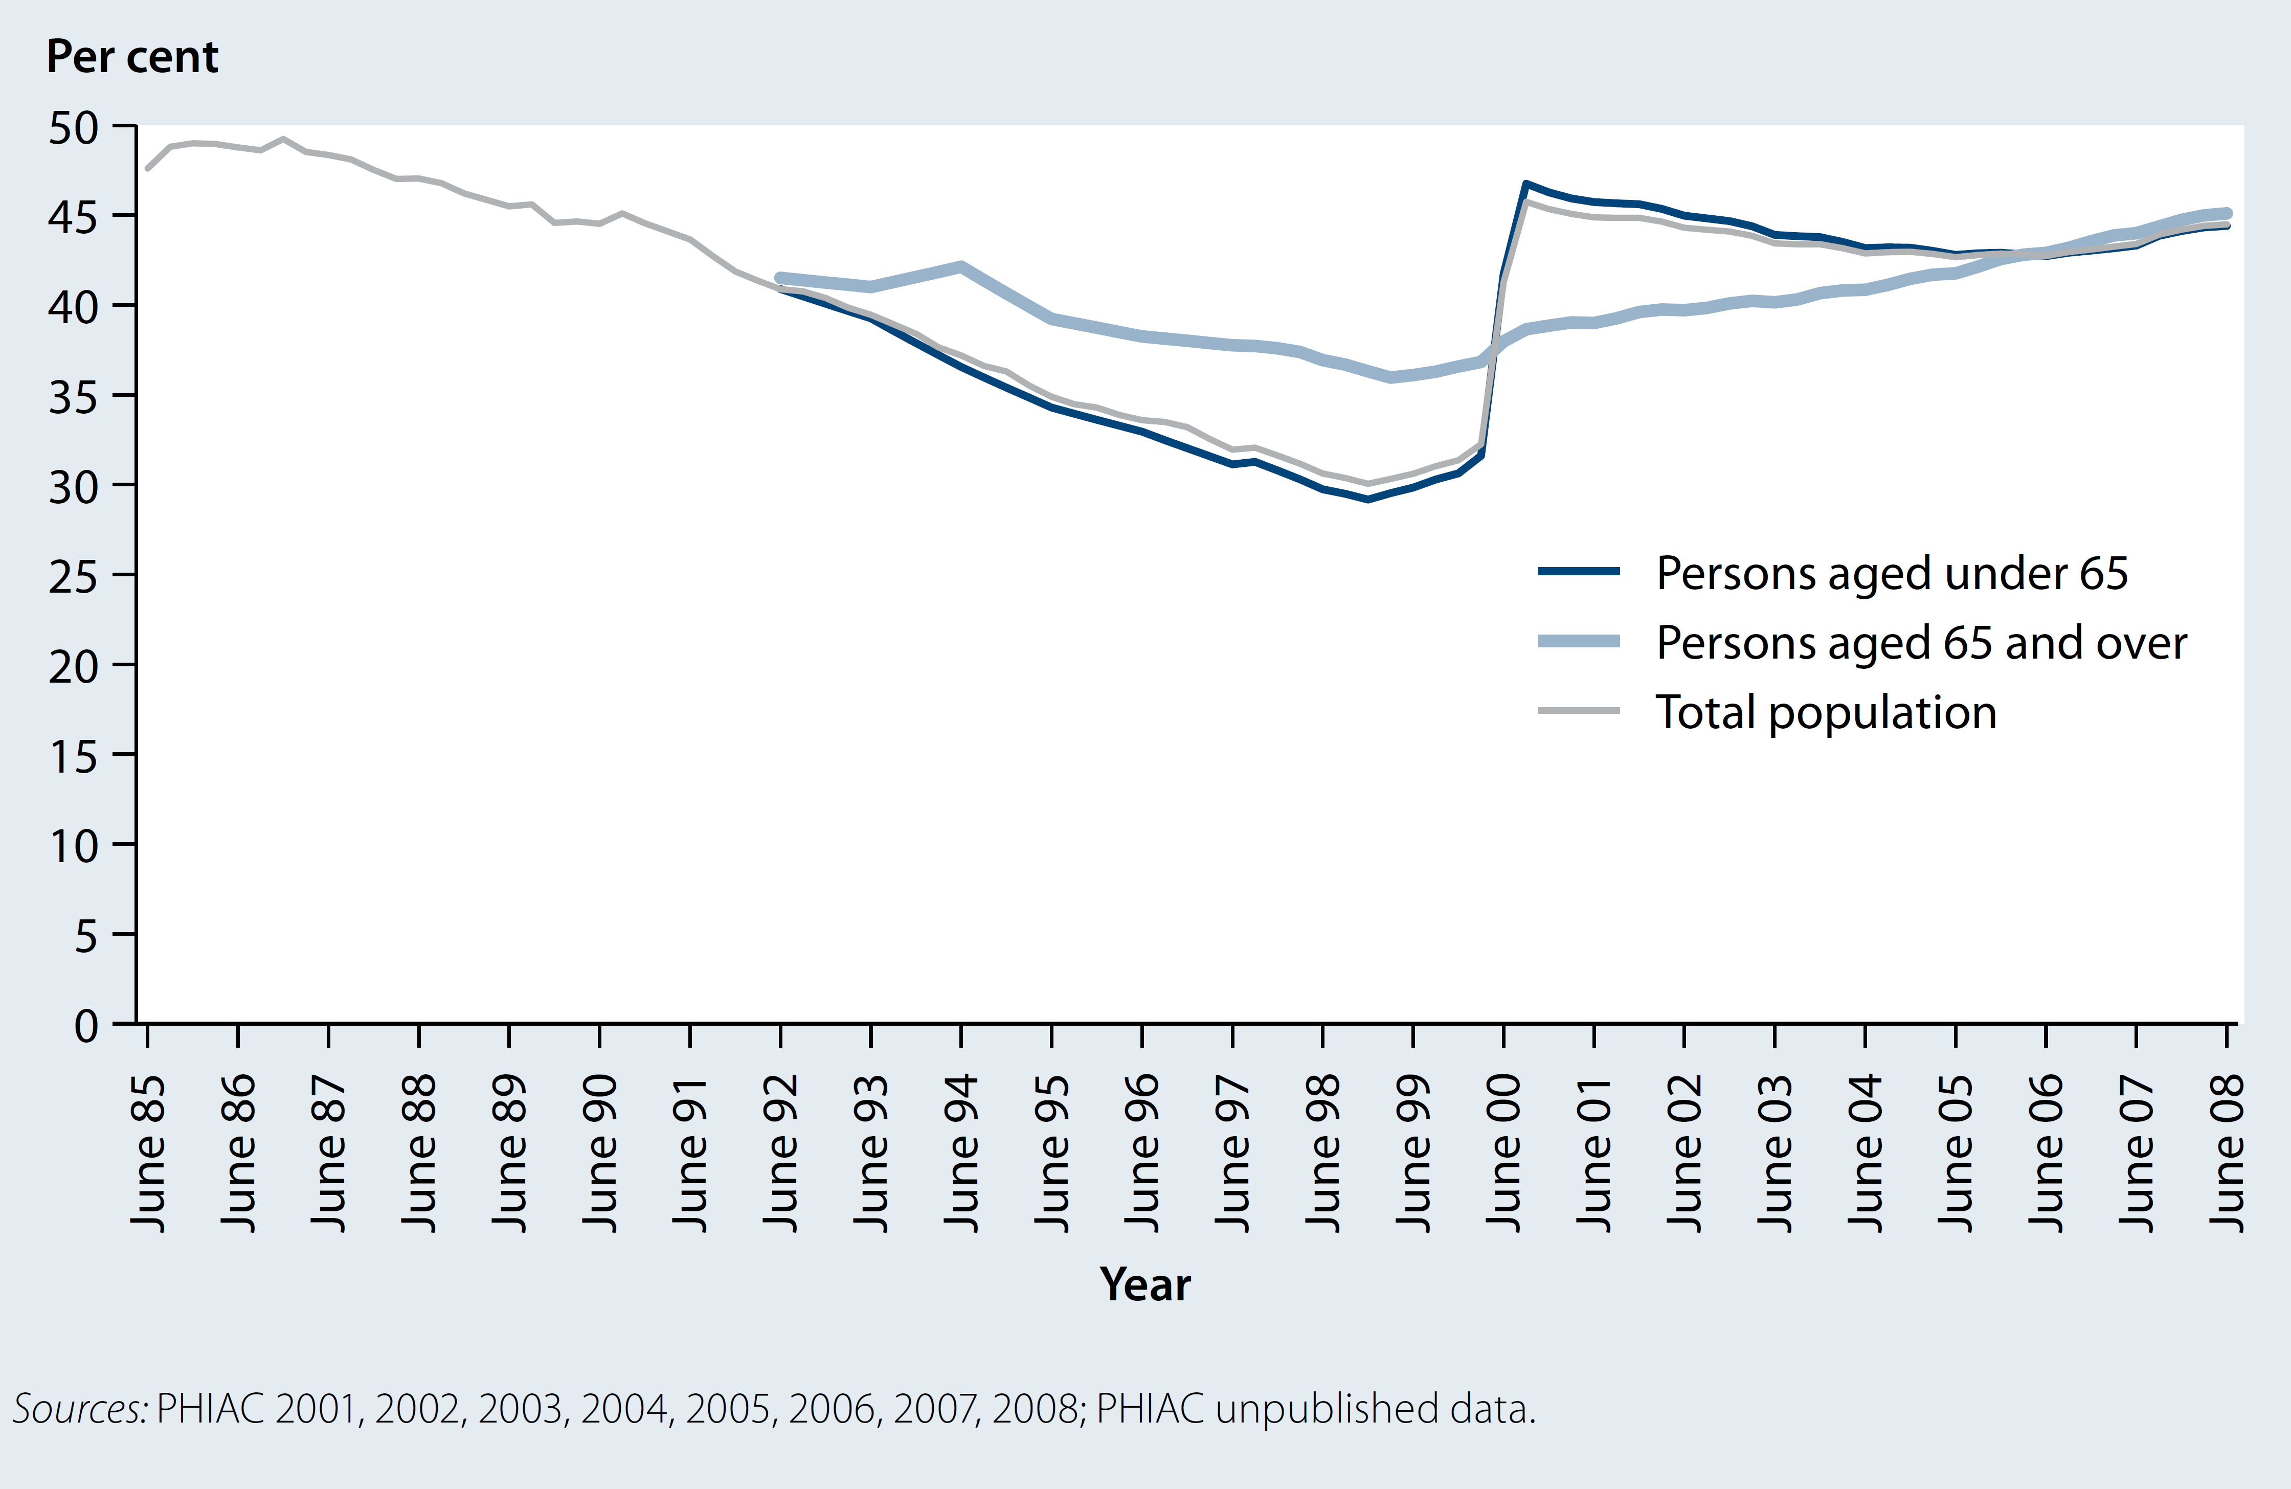

Source: AIHW, Australia’s Health, 2010. Page 417.

a. Explain the trend in private health insurance membership of the total population over time. 2 marks

|  |
| --- |
|  |
|  |
|  |
|  |

b. Identify and explain two incentives put in place by the Federal Government that may have resulted in the increases seen in 2000. 4 marks

|  |
| --- |
|  |
|  |
|  |
|  |
|  |
|  |
|  |

**Question 5**

The following graph shows health expenditure by type of health service and source of funds, 2007–08.

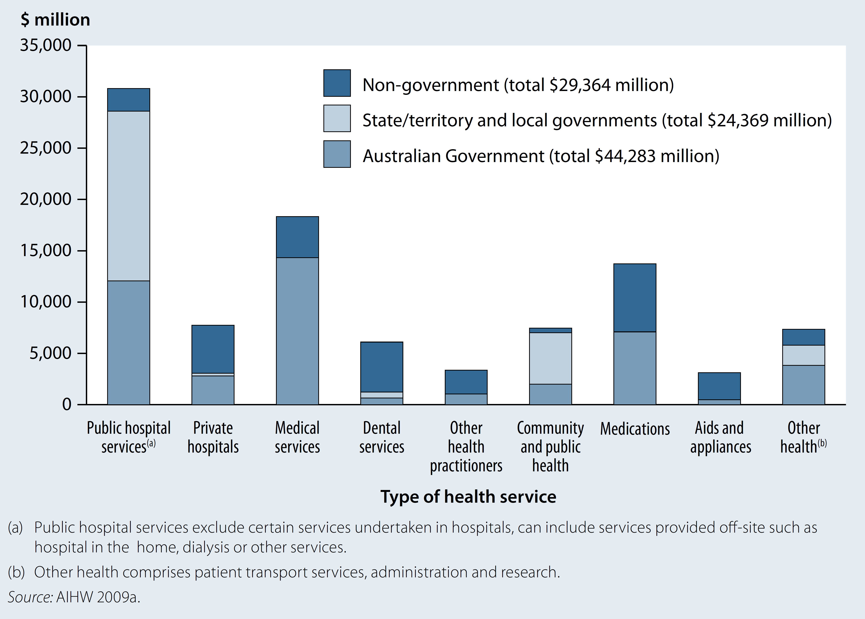

Source: AIHW, Australia’s Health, 2010. Page 432.

a. According to the above graph, what type of health service cost the most in 2007-08. 1 mark

|  |
| --- |
|  |

b. i. Which service had the highest non-government contribution? 1 mark

|  |
| --- |
|  |

ii. Would this service reflect the biomedical or social model of health? Justify your answer. 3 marks

|  |
| --- |
|  |
|  |
|  |
|  |
|  |
|  |

**Question 6**

Read the following case study about a VicHealth funded project and answer the questions that follow.

**VicHealth works to promote health and prevent the harmful effects of smoking by contributing to the funding of the Quit campaign.**   
  
VicHealth and [Quit](http://www.quit.org.au/) work with many aspects of smoking to reduce its harmful effects. These are our key strategies and activities.

**Assisting smokers to quit**

* Quitline telephone counselling and Quit courses
* media activity and campaigns
* programs supporting communities, such as Aboriginal and multicultural communities.

**Working to prevent young people from taking up smoking**

* support for legislation to increase the price of cigarettes, and restrict tobacco advertising, promotion and selling to under 18s
* smoking prevention education and professional development in schools
* community education programs encouraging adult role models
* Quit's sporting sponsorship with the SmokeFree message and a focus on prevention.

**Working to reduce the number of places where people are exposed to harmful substances in tobacco smoke**

* support for legislation to limit smoking in public places
* help for workplaces and public places wanting to become smokefree
* support for the SmokeFree message through sponsorship
* VicHealth's healthy environments policy, which maintains a tobacco control focus in its funding agreements - it states that funded indoor events must be smokefree.

**Supporting legislative policy change**

* collecting and distributing information on tobacco control issues to the public and a wide range of professionals
* participating in research into tobacco control issues
* publishing evaluation findings.

b. Describe 2 principles of the social model of health and explain how they are evident in the above program. 6 marks

|  |
| --- |
|  |
|  |
|  |
|  |
|  |
|  |
|  |
|  |
|  |
|  |
|  |

a. Briefly explain the role of VicHealth in promoting the health and wellbeing of Victorians. 2 marks

|  |
| --- |
|  |
|  |
|  |
|  |

**Question 7**

The following case study relates to a program developed by Brimbank City Council, a local government in Melbourne.

**Brimbank Council** is supporting local primary schools to promote students to actively travel to school through the Walking Wheeling Wednesdays program.

As part of the program, schools receive a $500.00 grant to co-ordinate two or more healthy breakfast events as an incentive for children to walk to school.

They also encourage children to walk to school every week on a Wednesday (or other designated day of the week).

Since the commencement of Walking Wheeling Wednesdays, 12 schools have participated and the program will soon be offered to all primary schools in Brimbank.

a. Outline how each dimension of health may be impacted by the Walking Wheeling Wednesdays program.

3 marks

Physical health and wellbeing

|  |
| --- |
|  |

Social Health and wellbeing

|  |
| --- |
|  |

Emotional health and wellbeing

|  |
| --- |
|  |

Mental Health and wellbeing

|  |
| --- |
|  |

Spiritual health and wellbeing

|  |
| --- |
|  |