Sample SAC tasks

Health and Human Development

Outcome 1 SAC – Structured Questions

**Name________________________________**

**Question 1** (4 marks)

Health and wellbeing is a subjective concept.

Explain health and wellbeing as a subjective concept.

______________________________________________________________________________________________________________________________________________________________________________________________________________________________________________________

____________________________________________________________________________________________________________________________________________________________________

____________________________________________________________________________________________________________________________________________________________________

__________________________________________________________________________________

**Question 2** (6 marks)

Jonah was recently diagnosed with depression.

1. Briefly describe mental health and wellbeing. 1 mark

______________________________________________________________________________________________________________________________________________________________

_______________________________________________________________________________

1. Use Jonah’s diagnoses to show the interrelationships between mental and physical health and

wellbeing. 2 marks

______________________________________________________________________________________________________________________________________________________________

_______________________________________________________________________________

_______________________________________________________________________________

Sarah has contracted the flu (influenza).

1. Briefly describe spiritual health and wellbeing. 1 mark

______________________________________________________________________________________________________________________________________________________________

_______________________________________________________________________________

1. Use Sarah’s illness to show interrelationships between physical and spiritual health and wellbeing. 2 marks

______________________________________________________________________________________________________________________________________________________________

_______________________________________________________________________________

_______________________________________________________________________________

**Question 3** (9 marks)

1. Using two examples, explain what is meant by ‘sustainable resources’. 3 marks

_______________________________________________________________________________

_______________________________________________________________________________

_______________________________________________________________________________

_______________________________________________________________________________

_______________________________________________________________________________

1. Besides peace and sustainable resources, identify two prerequisites for health as identified by the

World Health Organization and explain how each can contribute to improved health and

wellbeing. 6 marks

_______________________________________________________________________________

_______________________________________________________________________________

_______________________________________________________________________________

_______________________________________________________________________________

_______________________________________________________________________________

_______________________________________________________________________________

_______________________________________________________________________________

_______________________________________________________________________________

_______________________________________________________________________________

_______________________________________________________________________________

**Question 4**  (6 marks)

1. Explain why health and wellbeing is important for individuals. 3 marks

_______________________________________________________________________________

_______________________________________________________________________________

_______________________________________________________________________________

_______________________________________________________________________________

_______________________________________________________________________________

_______________________________________________________________________________

1. Explain why health and wellbeing is important from a national (or country) perspective. 3 marks

_______________________________________________________________________________

_______________________________________________________________________________

_______________________________________________________________________________

_______________________________________________________________________________

_______________________________________________________________________________

_______________________________________________________________________________

---------------------------------------------------------------------------------------------------------------------------

**Question 5** (5 marks)

A range of factors impact health status in Australia.

1. Explain what is meant by biological factors. 1 mark

_______________________________________________________________________________

_______________________________________________________________________________

_______________________________________________________________________________

1. Use two biological factors to explain differences in health status between males and females in

Australia. 4 marks

_______________________________________________________________________________

_______________________________________________________________________________

_______________________________________________________________________________

_______________________________________________________________________________

_______________________________________________________________________________

_______________________________________________________________________________

_______________________________________________________________________________

**Question 6**  (8 marks)

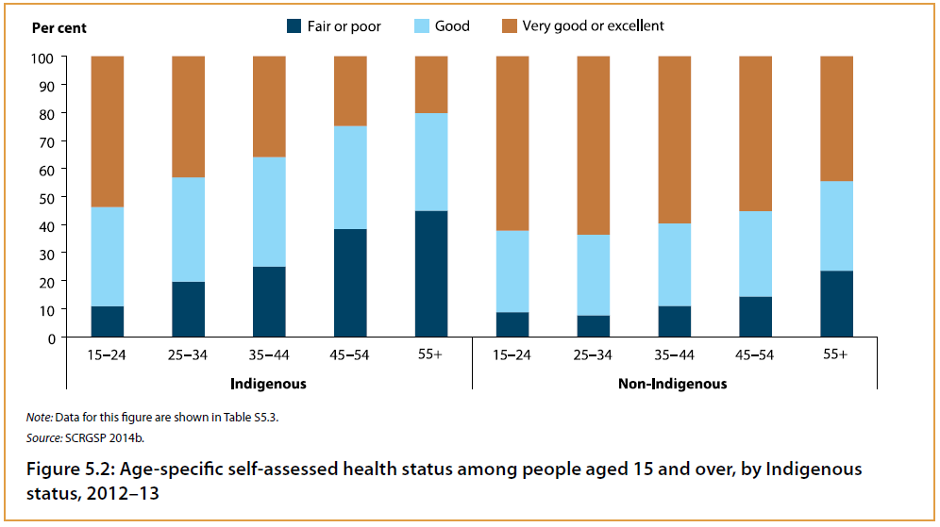

1. Briefly explain self-assessed health status. 1 mark

_______________________________________________________________________________

_______________________________________________________________________________

_______________________________________________________________________________

1. Using data, briefly describe the difference in the proportion of Indigenous Australians assessing

their health status as very good or excellent. 3 marks

_______________________________________________________________________________

_______________________________________________________________________________

_______________________________________________________________________________

_______________________________________________________________________________

_______________________________________________________________________________

_______________________________________________________________________________

1. Using two sociocultural factors as the basis of your response, explain possible reasons for the

difference described in part b. 4 marks

_______________________________________________________________________________

_______________________________________________________________________________

_______________________________________________________________________________

_______________________________________________________________________________

_______________________________________________________________________________

_______________________________________________________________________________

_______________________________________________________________________________

_______________________________________________________________________________

**Question 7** (12 marks)

A range of factors influence health status and burden of disease in Australia, including body mass index and dietary risks.

1. Explain what is meant by body mass index. 2 marks

_______________________________________________________________________________

_______________________________________________________________________________

_______________________________________________________________________________

_______________________________________________________________________________

1. Outline two ways that high body mass index contributes to the burden of disease in Australia. 2 marks

_______________________________________________________________________________

_______________________________________________________________________________

_______________________________________________________________________________

_______________________________________________________________________________

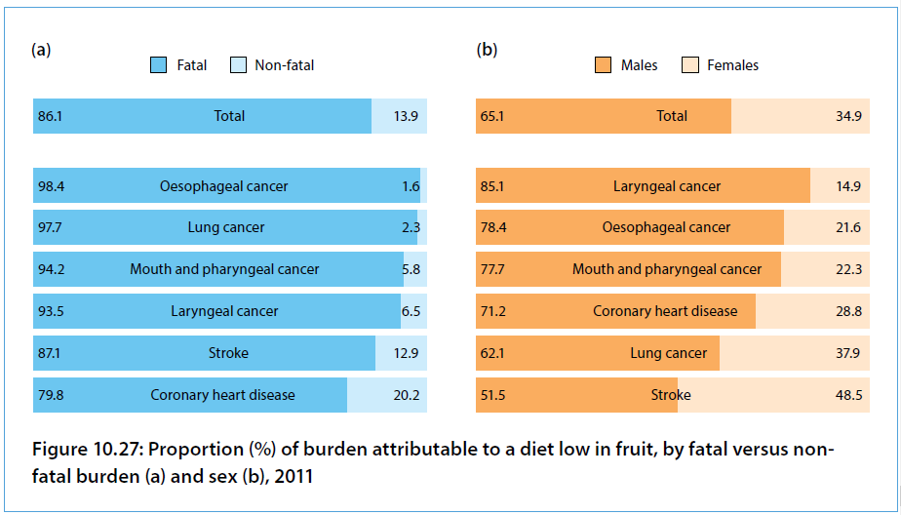The following graph shows the burden of disease attributable to low fruit intake.

Source: AIHW, Burden of disease Study 2011, 2016.

1. Explain what is meant by burden of disease. 2 marks

_______________________________________________________________________________

_______________________________________________________________________________

_______________________________________________________________________________

_______________________________________________________________________________

1. Compare the proportion of DALYs caused by low intake of fruit attributed to males compared to

females. 2 marks

_______________________________________________________________________________

_______________________________________________________________________________

_______________________________________________________________________________

1. Identify the condition for which inadequate intake of fruit caused the greatest proportion of disease

burden through fatal outcomes. 1 mark

_______________________________________________________________________________

1. Identify the condition for which inadequate intake of fruit caused the greatest proportion of disease

burden through non-fatal outcomes. 1 mark

_______________________________________________________________________________

1. Besides inadequate fruit intake, identify one dietary risk and explain how it contributes to burden of

disease in Australia. 2 marks

_______________________________________________________________________________

_______________________________________________________________________________

_______________________________________________________________________________

_______________________________________________________________________________