**Short answer Question – Variations in Population groups.**

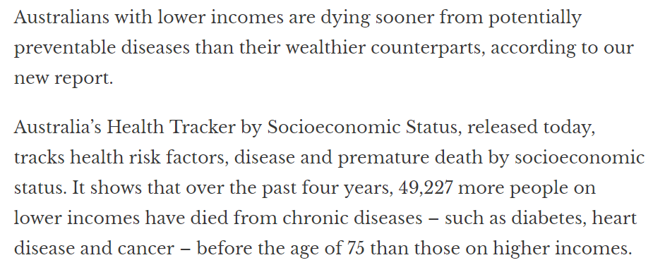

**a.** Identify the two indicators of health status used above. 2 marks

______________________________________________________________________________________________________________________________________________________

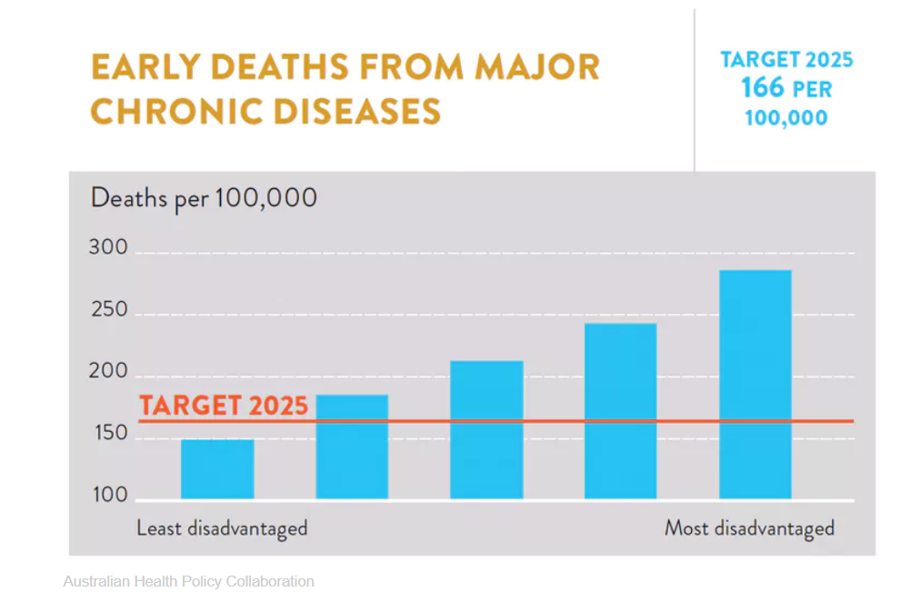

**bi.** The data above is measured in quintiles, from the least disadvantaged to the most disadvantaged population groups.

Explain what quintiles are. 1 mark

______________________________________________________________________________________________________________________________________________________

**bii.** List 3 chronic diseases which may cause early deaths in the most disadvantaged group. 3 marks

_________________________________________________________________________________________________________________________________________________________________________________________________________________________________

**biii.** Identify the population group unlikely to reach the 2025 target. 1 mark

___________________________________________________________________________

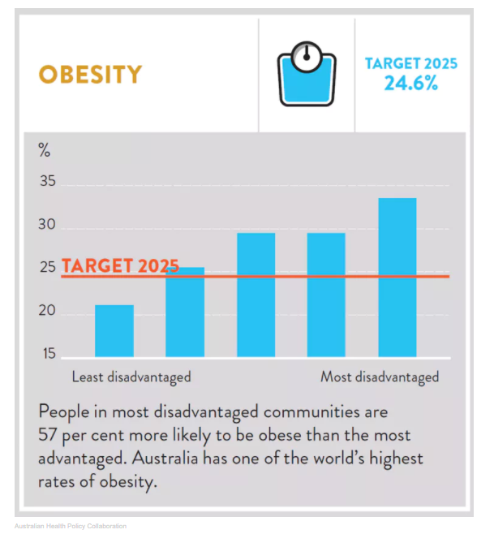

**ci.** Describe two trends from the graph above. 2 marks

1. ___________________________________________________________________________

___________________________________________________________________________

2.

___________________________________________________________________________

___________________________________________________________________________

**cii.** Biological, environmental and sociocultural factors can contribute to variations in health status between population groups.

Select one example each for the three factors and explain how these could contribute to the trends identified in **part ci**. 6 marks

Biological _________________________________

___________________________________________________________________________

___________________________________________________________________________

___________________________________________________________________________

___________________________________________________________________________

Environmental _____________________________

___________________________________________________________________________

___________________________________________________________________________

___________________________________________________________________________

___________________________________________________________________________

Sociocultural ______________________________

___________________________________________________________________________

___________________________________________________________________________

___________________________________________________________________________

___________________________________________________________________________

**d) Males and Females – Dietary factors (Calcium and Iron)**

Refer to the following tables taken from the <https://www.aihw.gov.au/getmedia/5fc6d6be-dcec-458e-af63-2e6c90589bd8/Nutrition-across-the-lifestages-in-brief-aihw-phe-227.pdf.aspx>

**Males** 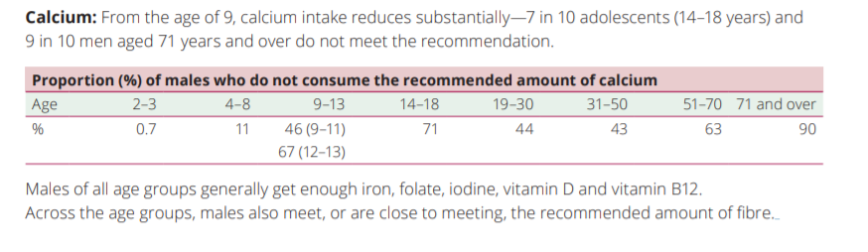

**Females**

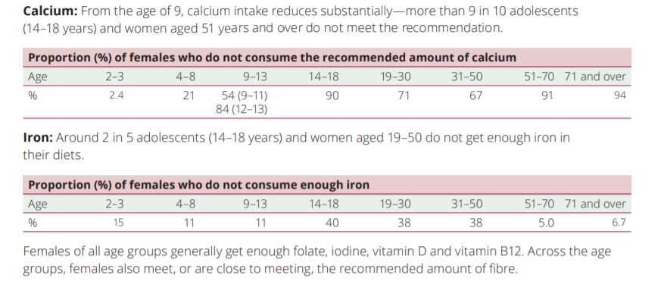

1. Compare the percentage of males and females between aged 14-18 years who do not meet their Recommended Dietary Intake of Calcium and Iron. (2 marks)

___________________________________________________________________________

___________________________________________________________________________

___________________________________________________________________________

___________________________________________________________________________

1. Identify reasons **and** the factor/s (**socio-cultural, biological, or environmental**) that might explain the differences in **calcium** and **iron** intake between males and females at various ages. (2+2=4 marks)

___________________________________________________________________________

___________________________________________________________________________

___________________________________________________________________________

___________________________________________________________________________

___________________________________________________________________________

___________________________________________________________________________

___________________________________________________________________________

___________________________________________________________________________

1. Use the data below to outline the impact on the health status of males and female over time (2+2=4 marks)









