**Short answer Question – Variations in Population groups.**

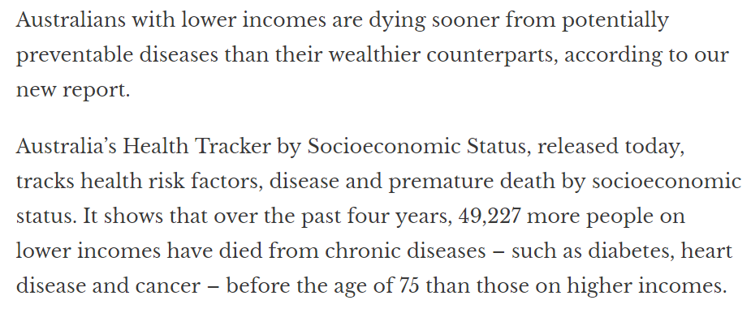

**a.** Identify the two indicators of health status used above. 2 marks

YLL – Years of Life Lost OR Mortality

YLD – Years of Life Lost due to Disability OR Morbidity

For 2 marks – must have full description if citing YLL or YLD

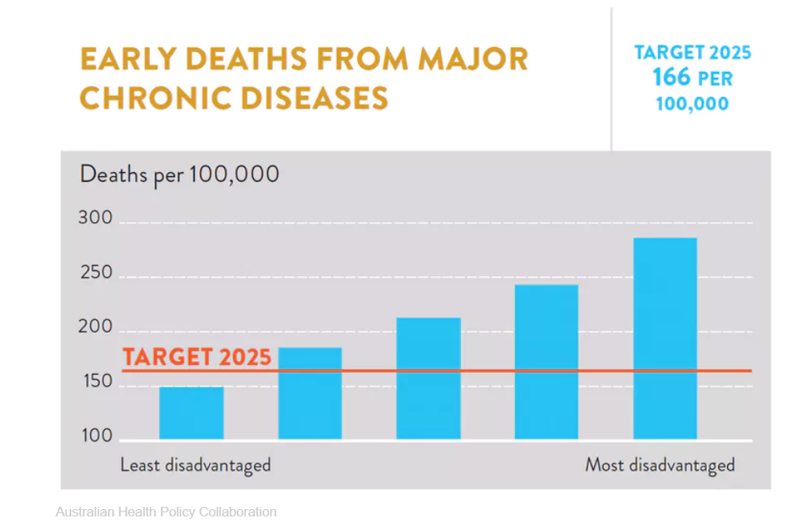

**bi.** The data above is measured in quintiles, from the least disadvantaged to the most disadvantaged population groups.

Explain what quintiles are. 1 mark

Five classification of variance in a condition (eg. in this case least disadvantaged to most disadvantaged). For full mark must include a description as well as supplying an eg. Citing eg only no marks.

**bii.** List 3 chronic diseases which may cause early deaths in the most disadvantaged group. 3 marks

CVD –stroke, coronary heart disease

Cancer- skin, lung

Complications from Type II Diabetes – eg kidney failure

(maybe?) Suicide due to chronic mental health and wellbeing condition

Any one of the above awarded 1 mark (but no double dipping eg stroke, coronary heart disease)

**biii.** Identify the population group unlikely to reach the 2025 target. 1 mark

Most disadvantaged

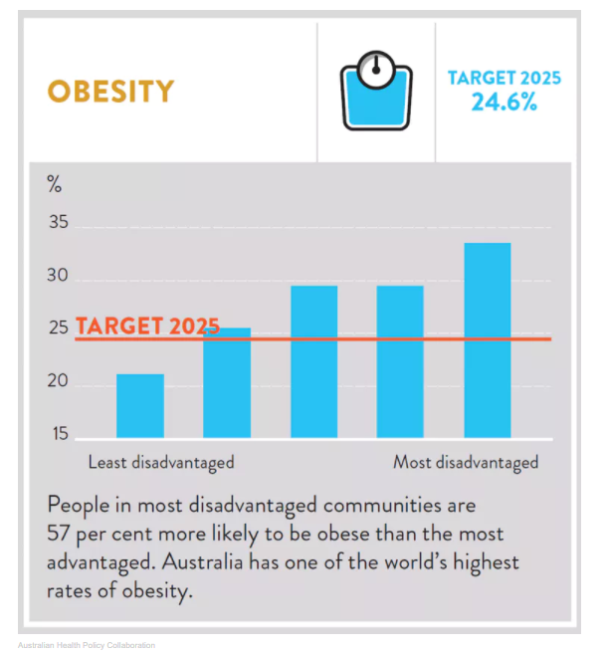

**ci.** Describe two trends from the graph above. (not an exhaustive list – others may apply. See eg below) 2 marks

1. The least disadvantaged are the only quintile group with a 20% obesity prevalence that are already below and have ‘met’ the 2025 24.6% target.

2. The second to fifth quintile group representing increasing levels of disadvantage are up to 10% higher than the 2025 target of 24.5%

For two marks MUST include (accurate transcription of) data from the table

**cii.** Biological, environmental and sociocultural factors can contribute to variations in health status between population groups.

Select one example each for the three factors and explain how these could contribute to the trends identified in **part ci**. 6 marks

Eg of 2 marks – must state the group or individuals at risk (eg low SES + males for Biological)

**Biological _**

Those larger (ectomorphic) body types (ie represented as ‘apple-shaped’ in the text) are more likely to be **male** who are at higher risk of obesity due to more visceral fat (abdominal fat around vital organs) that elevates risk of CVD.

**Environmental**

* “Obesogenic” environment in areas with high populations with low SES and with easy access to convenience food or ultra-processed food high in fat and kJs) may encourage individuals to purchase these foods
* Rural/remote – increased cost of purchasing or lowered access to purchase fresh foods especially vegetables and fruit.

**Sociocultural**

* Recently arrived immigrants move away from nutritious traditional diets and uptake local food that is high in fat and kJs and that is not part of their regular diet.
* Lack of food skills, time and energy even if the groups know the benefits of eating well balanced diet. This may be die to socio-cultural factors such as working night shift, lack of private transport to access cheaper fresh foods further away, language barriers/low literacy such as not able to read food labels

**d) Males and Females – Dietary factors (Calcium and Iron)**

Refer to the following tables taken from the <https://www.aihw.gov.au/getmedia/5fc6d6be-dcec-458e-af63-2e6c90589bd8/Nutrition-across-the-lifestages-in-brief-aihw-phe-227.pdf.aspx>

**Males** 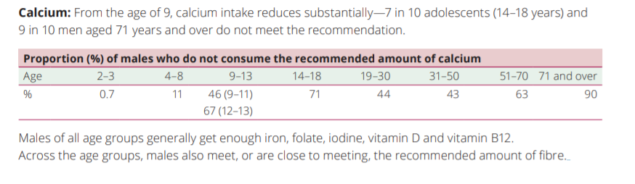

**Females**

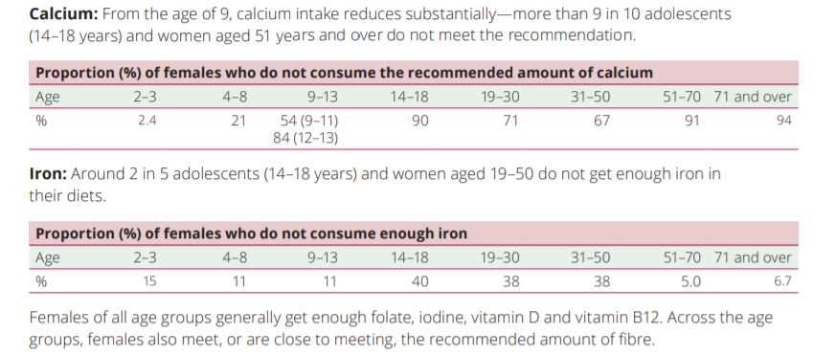

1. Compare the percentage of males and females between aged 14-18 years who do not meet their Recommended Dietary Intake of Calcium and Iron. (2 marks)

Males are more likely to meet their iron requirements compared 60% females of the same age.

Two-thirds (71%) of males compared to 90% of females do not meet their Calcium requirements

For the full two marks – need to include BOTH males and females AND calcium and iron.

1. Identify reasons **and** the factor/s (**socio-cultural, biological, or environmental**) that might explain the differences in **calcium** and **iron** intake between males and females at various ages. (2+2=4 marks)

**Biological**

**Calcium -** post-menopausal femalesno longer have the protective effect of the hormone oestrogen that maintains bone density and prevents osteoporosis. Bone density increases and maximises at 25 years old in females, maintained until menopause and then decreases over time post-menopause. Further, bone density is further depleted during pregnancy (Calcium is required for foetal osteogenesis (bone-making)) and breastfeeding (calcium used in milk production) if the mother decides to breastfeed her infant.

Osteoporosis is prevalent in small, thin-boned women (eg. Asian cultural background)

**Iron –** menstrual losses in young women, especially compounded with them electing a vegetarian diet and/or inadequate diet low in iron sources.

**Socio-cultural**

Calcium - For young adults, move away from dairy products – perceived as high energy food (4% fat in full cream milk compared with 38% fat content in chocolate biscuit), peer group, asserting independence means that young people may adopt habits such as skipping breakfast. Parents no longer in control of ensuring that breakfast is consumed (cereal and milk) by their teenage children.

Iron (Fe) – young women may elect a vegetarian diet that may put them at risk of not meeting their iron requirements as they no longer eat red meat (rich source of haem-iron).

**Environmental - ??**

**Biological and Socio-cultural** are probably the two most likely factors. For four marks – 2 marks for addressing each of the nutrients (calcium and iron) and 2 marks for addressing the factors - socio-cultural and biological.

Refer to the data below to outline the impact on the health status of males and female over time (2+2=4 marks)

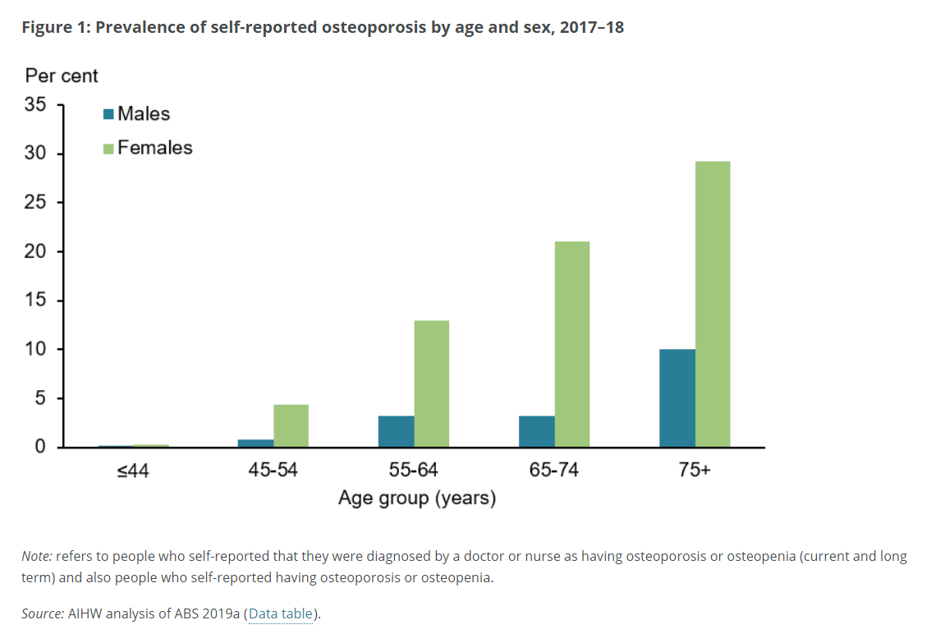

Females are more likely to self-report up to 3x the levels of osteoporosis than males of the same age category. (1 mark).

For example, at age 45-54 years, females 3% and males 1%; at 65 -74 years 15% for females and 5% males. (1 mark)

1 mark for general statement and 1 mark for the eg using data.