**Question 1** (14 marks)

The following graphs show the proportion of people with access to safe water and adequate sanitation in Australia, middle-income and low-income countries.

Source: Adapted from WHO data, 2018.

1. Briefly outline the difference between clean water and sanitation. 2 marks

clean water refers to water that is safe for human consumption and is not contaminated with disease causing pathogens such as bacteria and viruses, or chemicals such as lead and mercury. whereas sanitation refers to the process of eliminating contact between humans and hazardous wastes such as domestic animal faeces and urine, wastewater, industrial and agricultural wastes.

1. Using data, outline the difference in the proportion of those who have access to safe water and

adequate sanitation between Australia, middle- and low-income countries. 4 marks

the access to safe water and adequate sanitation is responsible for a large proportion of the variations in health and wellbeing between australia, middle-, and low-income countries. in 2006, 48% of those in low-income countries had less access to safe water than those in middle- and high-income countries (australia) highlighting over 85%, fortunately in 2015 the access to safe water in low-income countries had increased at 53%. typically, women and children in these countries may spend most of their time travelling to collect water compared to people in middle- and high-income countries already having access to water sources that is clean and able to be used for drinking, crops, and livestock. the access to adequate sanitation in australia was 100% from 2006 until 2015, whereas the proportion of those who had access in low-, and middle-income countries increased by 3% throughout nine years.

1. Briefly explain how the differences outlined in part b. contribute to differences in health status between

Australia and low-income countries. 4 marks

communities in low-income countries are more likely to have a lack of access to safe water while also suffering from the lack of sanitation systems, this contributes to an increased burden of disease and lower health status within the community. those living in remote and rural areas may experience a lack of access to safe water and sanitation as the infrastructure required to provide these resources is often unavailable. the lack of access to clean water in proximity may mean that women and children have to carry heavy loads for long distances, increasing musculoskeletal conditions and increasing YLD’s. if contaminated water is consumed, this then increases the risk of water-borne diseases such as cholera and malaria, leading to increased YLL’s. although water is essential for growing crops, a lack of water can diminish the natural environment making it difficult to grow crops, reducing food security leading to hunger and malnutrition for the population, increasing levels of morbidity. australia has a well-established and reliable water supply, although interruptions to this supply are sometimes experienced in some remote indigenous communities, resulting from natural disasters and floods.

1. Besides water and sanitation, outline two factors or characteristics that may contribute to reduced access

to clean water in low-income countries when compared to Australia. 4 marks

although australia, has a well-established and reliable water supply, interruptions to this supply are sometimes experienced in remote indigenous communities, resulted from natural disasters such as floods. low- and middle- income countries are at greater risk of the effects of unsafe water, as they are less likely to have the infrastructure to supply clean drinking water, especially in rural and remote areas. governments of these countries often lack strict controls on water quality and monitoring, or the money to provide clean water to those who need it. children in low- and low-middle income countries are particularly vulnerable to the impacts of unsafe water as they are likely to experience repeated infection from collecting contaminated water, while accounting for a high proportion of the total deaths from water related causes including undernutrition.

**Question 2** (2 marks)

The following table shows a range of indicators for Australia and Rwanda, a low-income country in Africa.

|  |  |  |  |  |  |  |
| --- | --- | --- | --- | --- | --- | --- |
|  | **GNI per capita ($)** | **U5MR (per 1000 live births)** | **Life expectancy (both sexes)** | **Access to electricity (% of population)** | **Maternal mortality (per 100 000 live births)** | **Current health expenditure (US$) per capita** |
| **Australia** | 45 210 | 3.7 | 82.8 | 100 | 6 | 4 934 |
| **Rwanda** | 1 860 | 38.5 | 66.1 | 29 | 290 | 57 |

Source: WHO and World Bank, 2018.

Using data, draw a conclusion relating to health status in Australia compared to Rwanda.

health status in australia is better than that in rwanda according to the data presented in the table above. the under-five mortality rate is lower in australia than rwanda at 3.7 and 38.5 deaths per 1000 live births respectively. safe water and sanitation may be more readily in available for those un australia compared to those in rwanda, which can contribute to this difference. children are often the most susceptible to conditions, such as cholera, which can occur when clean water and sanitation are not readily available. these conditions can cause death and may contribute to the difference in the under-five mortality rate between the two countries. rwanda’s GNI per capita at $1860 puts them in the low-income country bracket compared to australia at $45210 therefore being classified as a high-income country.

**Question 3** (9 marks)

1. Briefly explain what is meant by global marketing of tobacco. 1 mark

the global marketing of tobacco refers to multi-national brands advertising and selling of tobacco goods and services on a global scale.

1. Explain why low-income countries are particularly susceptible to the distribution and marketing of

tobacco. 4 marks

low-income countries have been specifically targeted by manufactures of tobacco, therefore contributing to an increase in non-communicable diseases in these countries. as smoking rates have decreased in many high-income countries, the global distribution and marketing has increased in low-income countries in attempt to make up lost revenue experienced in high-income countries and to increase global sales. people in low-income countries tend to have lower levels of education, meaning they are more likely to see only the attractive side of the tobacco being marketed without considering the consequences of consumption. these countries often do not have strict laws or regulations such as no labelling laws, no regulations and no taxes on imported goods, which makes it easier for manufacturers in high-income countries to sell their brand of tobacco and tend to make a lot of sales in low-income countries.

1. Explain how the marketing of tobacco may influence health and wellbeing and burden of disease

in low-income countries. 4 marks

people in low-income countries are more likely to smoke more cigarettes as they are often sold individually and therefore more accessible, potentially leading to atherosclerosis and an increase in DALY’s. those that are less educated are more likely to start smoking from a young age, which reduces the life expectancy in low-income countries. there are also likely to be more people who will be breathing in second-hand tobacco smoke, meaning people are likely to suffer from respiratory diseases such as asthma, which decreases the health adjusted life expectancy for these countries.

**Question 4** (17 marks)

Climate change contributes to extreme weather events, including natural disasters.

**Source 1:** The following image shows the types of events that are a part of each subgroup of natural disasters:

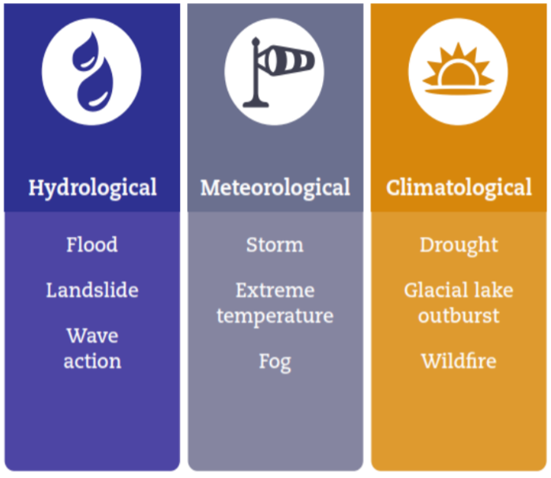

Source: Guha-Sapir D, Hoyois Ph., Below. R. Annual Disaster Statistical Review 2016: The Numbers and Trends, 2016.

**Source 2:**

The following graph shows the number of extreme weather events (according to the subgroup of events experienced) and the number of deaths from those events that occurred in 2016 in India and the USA.

Source: Adapted from <http://www.cred.be/sites/default/files/ADSR_2016.pdf>

**Source 3:**

|  |  |  |
| --- | --- | --- |
|  | **Average income (US$)** | **Population (number)** |
| **India** | 1 706 | 1 324 171 350 |
| **USA** | 57 638 | 323 127 510 |

Source: World Bank, 2018.

1. Outline the difference in the total number of natural disasters and the number of deaths from those

disasters in India compared to the USA. 2 marks

the trend between india and the united states shown in the graph (source two) is the increase in the implications of climate change. in this case, it is the increase in mortality rates from extreme weather events. both countries had shown an increase in deaths from extreme weather events over the year of 2016, however, there was a variance of the types of events that were targeting india and USA. about 1250 deaths were caused by 25 meteorological events which mostly contributed to the mortality rates for USA, in india, mortality rates were caused by 12 hydrological events and lead to around 600 deaths.

1. Using information presented in this section and your own knowledge, explain two reasons for the difference in mortality

due to natural disasters between India and the USA. 4 marks

as demonstrated in source two, there were greater mortality rates instigated by natural disasters in india, highlighting around 23 deaths compared to the USA demonstrating 5 deaths. hydrological events such as flooding is responsible for drownings and physical injuries, in india, the health system is unable to supply people with treatment leading to an increase in mortality rates, compared to the united states who are able to give access to more injured or sick citizens, leading to fewer deaths. meteorological events such as cyclones contributed to the mortality rates in the USA as they are most common in the atlantic ocean, these events destroy vegetation eventually impacting communities by damaging plant and animal sources. although, in india meteorological events did not contribute as much to the mortality rates compared to the united states.

1. Besides the risk of premature death, discuss three possible impacts on the health and wellbeing of those exposed to  
   extreme weather events. 3 marks

the climate and weather are changing due to an increase in global warming, increasing the commonality of extreme weather

events and threatening the health and wellbeing of those who are exposed. warmer waters and flooding may increase exposure

to diseases in drinking and recreational waters, demonstrating a reduced access to fresh water. the contamination of stored

water from floods means that clean water becomes unavailable for drinking, increasing the incidence of water-borne diseases

such as diarrhoea, while affecting physical health and wellbeing. in low-income countries, increased homelessness is likely to be greater due to the impact of extreme temperatures and the lack of resources to cope with natural disasters, often leaving people homeless or displaced, demonstrating poor emotional and mental health and wellbeing. with increased hunger and undernutrition

in some countries who do not have enough food, a child’s opportunity to attend school and develop social connections is reduced, impacting social health and wellbeing.

1. Explain two likely differences in human development between India and the USA based on their respective average

incomes. 4 marks

human development is about much more than income, it is about creating an environment in which people can develop to their

full potential and lead productive, creative lives according to their needs and interests. education can develop capabilities in

relation to numeracy and literacy. with these skills, a person is likely to have more choice in relation to the careers they pursue in

the future, in the USA a greater income may be demonstrated from children receiving education and getting a stable job while creating an average income of $57638. those in india may miss multiple school days each year through a combination of ill-health

and time spent collecting water, reducing levels of education and the potential to earn a decent income of $1706 in the future.

deprivation presents as a lack of material resources such as basic necessities (food, shelter, and clean water), resulting in poverty.

the gross national income affects the government’s ability to provide resources to its citizens, those experiencing poverty have

higher rates of communicable disease and/or child and adult mortality, whereas high-income countries (USA) may not experience

the struggle of trying to provide for its population (Indian government).

1. Outline two strengths and two limitations of the Human Development Index (HDI). 4 marks

the human development index is not only a measure of the level of human development in a country, however, it also takes into account various advantages and limitations for a population. it acknowledges and address the broader socioeconomic factors impacting human development, although it is not one dimensional, it combines dimensions of health, education and living standards. the single statistical measure between 0-1 may highlight a comparison between different countries, however, it does not tell us anything about individual dimensions. low-income countries may not have reliable data for the indicators such as life expectancy at birth or mean years of schooling due to not everything (e.g. birth and death) being record by the government, therefore, the HDI may be inaccurate.

**Question 5** (8 marks)

1. Using examples, explain the difference between social and economic sustainability. 4 marks

social sustainability relates to creating an equitable society that meets the needs of all citizens and can be maintained indefinitely, an equitable society highlights upholding human rights, encourages community participation, provides equal access to resources, and allows people to participate in making decisions that impact their lives. to ensure social sustainability for both current and future generations a number of factors need to be considered such as safe and decent working conditions, political and legal rights, peace and security, gender equality, and social protection systems. whereas economic sustainability relates to ensuring that average incomes in all countries are adequate to sustain a decent standard of living and continue to rise in line with inflation and living costs in the future. economic sustainability promotes the government to use resources and managing funds to ensure services and infrastructure are provided for current and future generations. to help ensure economic sustainability for both current and future generations there are several considerations which are important such as the innovation and diversity of industries, employment, economic growth, and trade.

1. Outline two reasons why environmental sustainability is important for the promotion of health and

wellbeing in a global context. 4 marks

environmental sustainability highlights that people around the world will have ongoing access to clean water and air, reducing the risk of infectious and respiratory diseases which promotes physical health and wellbeing globally. it also means that people will be more able to attend school and work as they are less likely to be sick, which means that they can work towards their purpose in life, promoting spiritual health and wellbeing on a global scale.