**YEAR 12 HHD AOS 2: SAMPLE EXAM QUESTIONS**

**2018**

Question 1: Explain how changes in policy and practice relating to ‘old’ public health may have contributed to Australia’s health status over time. 4 marks

Question 2: What is meant by ‘new’ public health? 2 marks

Question 3: Analyse one way in which ‘new’ public health may have contributed to improvements in Australia’s life expectancy over time. 3 marks

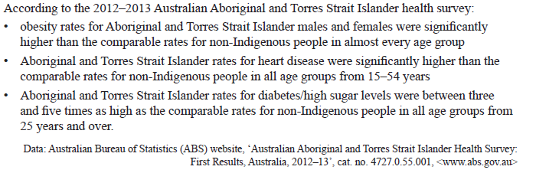

Question 4: Referring to information from the health survey above, explain how the Australian Dietary Guidelines could assist in improving Indigenous health status.

4 marks

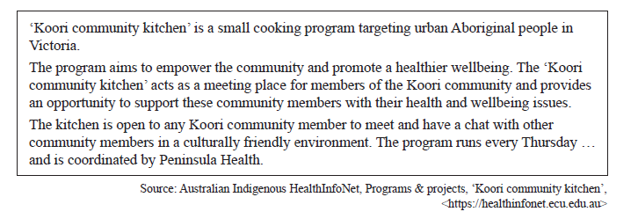Question 5: Identify and describe two action areas of the Ottawa Charter for Health Promotion that are reflected in the ’Koori community kitchen’ program and explain how they are evident. 6 marks

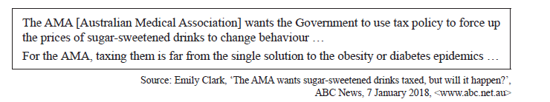

Question 6: Using the information of effective health promotion, including the Ottawa Charter for Health Promotion, explain why taxing soft drinks is not the solution to addressing the obesity epidemic. 6 marks

**2019**

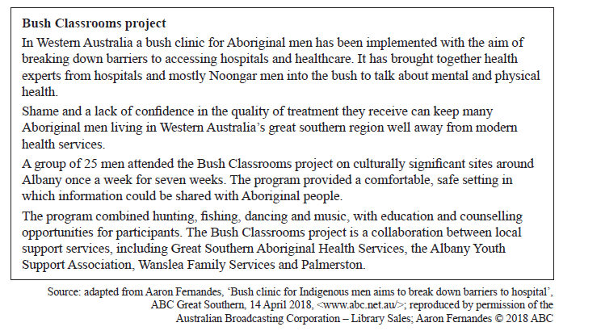

Question 1: Identify **one** principle of the social model of health and explain how it is refelcted in the Bush Classrooms project. 2 marks

As part of National Nutrition Week, Nutrition Australia launched the annual Tryfor5 campaign, which is designed to encourage Australians to increase their vegetable consumption to the recommended five serves per day.

Question 2: Explain how consuming the recommended five serves per day of vegetables would have an impact on the burden of disease in Australia. 3 marks

Question 3: In addition to National Nutrition Week, outline **one** other way in which Nutrition Australia promotes healthy eating. 2 marks

Question 4: Outline **two** disadvantages of the biomedical model of health. 2 marks

Question 5: Describe the Pharmaceutical Benefits Scheme (PBS). 1 mark

Question 6: Analyse how the PBS demonstrates sustainability and equity. 4 marks

Question 7: Select one of the following target areas for health promotion: skin cancer, smoking or road safety. Explain why health promotion was used to target this area.

2 marks

Question 8: Identify a health promotion program that focuses on the selected target area. Health promotion program _______________________________________

Describe how the implementation of this health promotion program reflects **two** actions areas of the Ottawa Charter for Health Promotion. 4 marks

Question 9: Evaluate this health promotion program’s effectiveness in promoting health and wellbeing in Australia. 3 marks